**AWS CLOUD INTERNSHIP --**

**Building a real-time small-scale application (Mart) using**

**various AWS services [11.8 tier Architecture]**

*A report submitted in partial fulfillment of the requirements for the Award of Degree of*

**BACHELOR OF TECHNOLOGY**

**In**

**Computer Science and Engineering**

**By**

**NALLALA MOHANA LAKSHMI**

**Under Supervision of Mr. Aashu dev**

**Blackbuck Engineers Pvt Ltd, Hyderabad**

**(Duration: 5th July 2023 to 5th September 2023)**



DEPARTMENT OF COMPUTER SCIENCE ENGINEERING

S.R.K.R. ENGINEERING COLLEGE

(Autonomous)

SRKR MARG, CHINNA AMIRAM, BHIMAVARAM-534204, A.P

(Recognized by A.I.C.T.E New Delhi) (Accredited by NBA & NAAC)

(Affiliated to JNTU, KAKINADA)

SAGI RAMA KRISHNAM RAJU ENGINEERING COLLEGE

(Autonomous)

DEPARTMENT OF COMPUTER SCIENCE ENGINEERING

CERTIFICATE

This is to certify that the Summer Internship Report titled “Building a real-time small-scale application (Mart) using various AWS services [11.8 tier Architecture]” is the bonafide work done by Ms. Nallala Mohana Lakshmi (21B91A05L0) at the end of second year second semester at Blackbuck Engineers Pvt Ltd, Hyderabad from 5th July 2023 to 5th September 2023in partial fulfillment of the requirements for the award of the degree of Bachelor of Technology in Computer Science and Engineering.

**Department Internship Coordinator Dean -T & P Cell Head of the Department**

**BLACKBUCK INTERNSHIP WORK**

• **NALLALA MOHANA LAKSHMI** (21B91A05L0)

**Title:**

**Building a real-time small-scale application (Mart) using various AWS services [11.8 tier Architecture]**

**Abstract:**

An Architecture of real-time small-scale application of Mart. This project mainly focused on uploading, manipulating and stock piling of data. In the list of AWS services S3 provides us with an additional feature of storing the versions of data and this data is transferred to DynamoDB by removing the duplicates which is a serverless NO SQL database for fast and flexible data. In this process a messaging service SNS is used to alert the subscribers on exceeding or lagging behind the specified threshold. Now RDS is the next entry of data for the high availability and for a promising purpose of backing up the statistics.

**Implementation of real time application (Mart) using various AWS services.**

***Introduction:***

A Small Scale Application (Mart):

In Real time managing the data is the crucial task for any industrialist. So we designed an application which deals with large datasets to get better of five dimensions of Big Data (5v’s). Including interconnectivity to stay tuned with regular customers and consumers.

Central Principal and Mechanism:

As for the principal, our main goal is to be in charge of organizing the data collected from various branches of a mart. We first establish two arms in same region and in different availability zones. Now we place two S3 buckets in these zones one in each. Now we gather and reflect the customer logs onto every bucket. Now we eliminate the twin data and transport the sole data into DynamoDb as permanent records for forthcoming. As this data can be only used for overall estimate we transport the data from S3 to RDS so that we can query the data as per our necessity.

Roles of AWS Services in Crafting the Architecture:

* Create VPC’s and launch EC2 Instances using AMI and create two buckets in each zone.
* Now we attach Lambda Trigger to S3 buckets.
* After that we Import data from S3 in DynamoDB.
* Now we redirect to CloudWatch by viewing the read metrics and erecting the Alerts.
* Now these Alert messages are sent to specified customers using SNS.
* As a back up storage we pile up the data in RDS using Glue by attaching an IAM role on behalf of glue for RDS full access.

**AWS Services Used:**

1. ***Virtual Private Cloud (VPC)***
2. ***Elastic Compute Cloud (EC2)***
3. ***Simple Storage Service(S3)***
4. ***Lambda***
5. ***Identity and Access Management (IAM)***
6. ***Cloud watch***
7. ***Simple Notification Service (SNS)***
8. ***DynamoDB***
9. ***Elastic Load Balancer (ELB)***
10. ***Glue***
11. ***Relational Database Service (RDS*)**
12. ***Data Base Migration Service (DMS)***

**AWS Subservices Used:**

1. *Internet Gateway*
2. *Peering Connections*
3. *Amazon Machine Images(AMI)*
4. *Elastic Ips*
5. *Trigger*
6. *IAM Users*
7. *Crawlers*
8. *Boot Strapping*

**Rough Architecture**

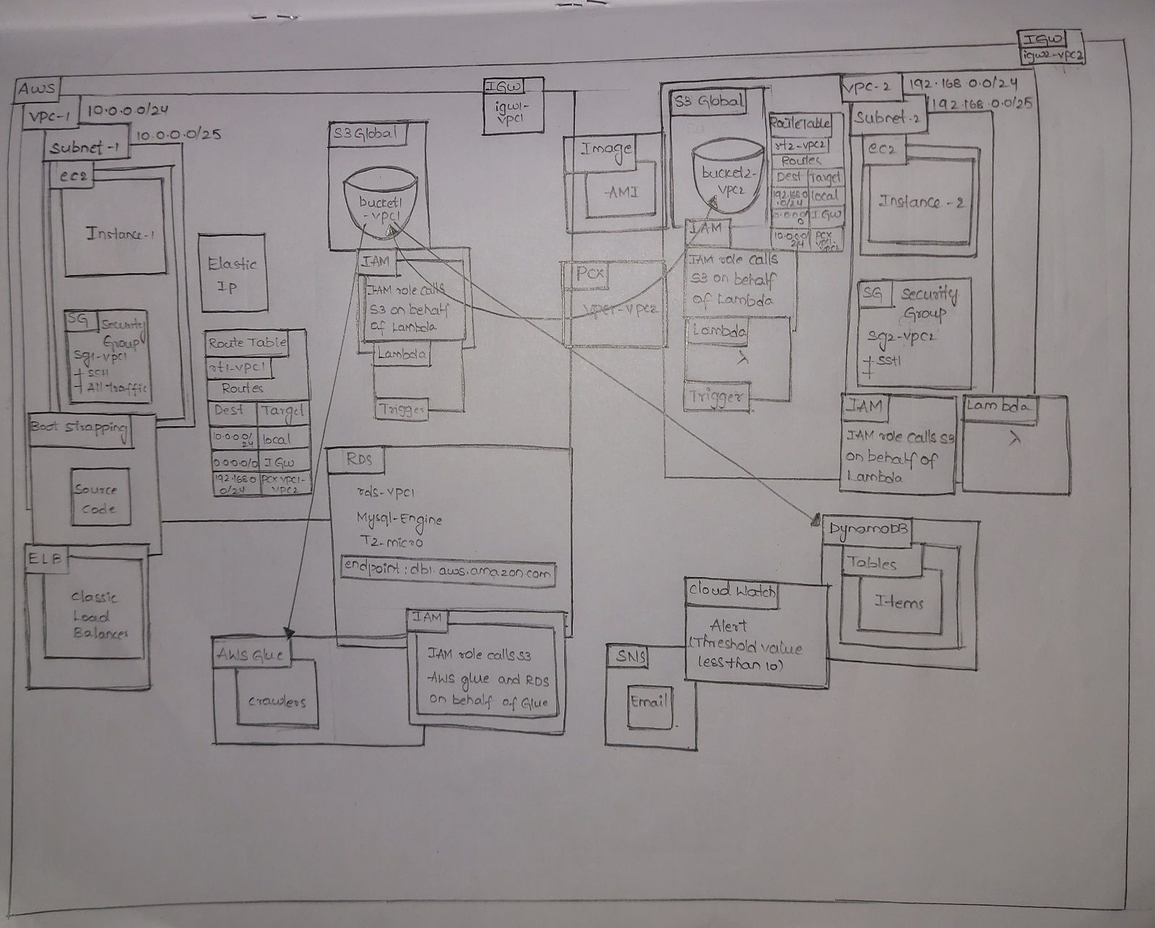

**Final Architecture**

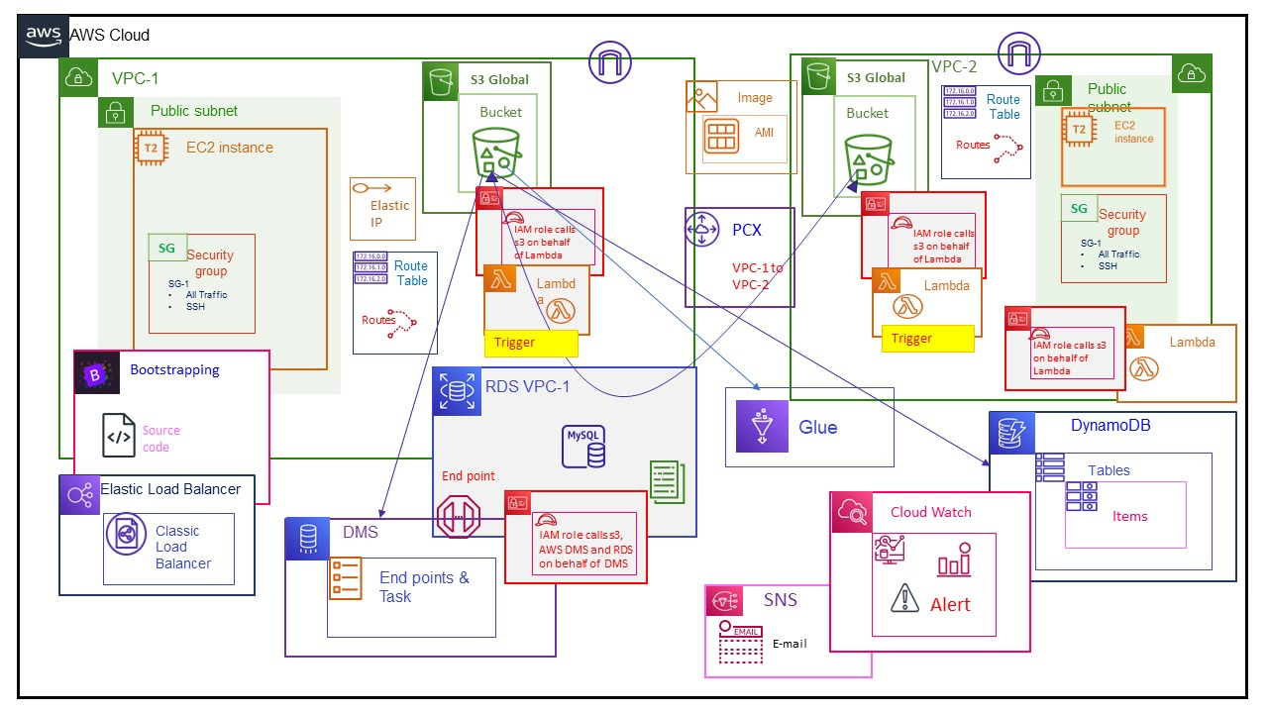

**Implementation of the Project**

Service 1: VPC



To create 2 VPCs with the name "VPC1,VPC2" follow these steps:

* Sign into the AWS Management Console.
* Open the Virtual Private Cloud Service.
* Click on the "Create VPC" option.
* Give the first VPC name as vpc1 and CIDR value as 10.0.0.0/24
* Click on create VPC.
* Similarly create the second VPC name as vpc2 and CIDR value as 192.168.0.0/24
* Click on create VPC

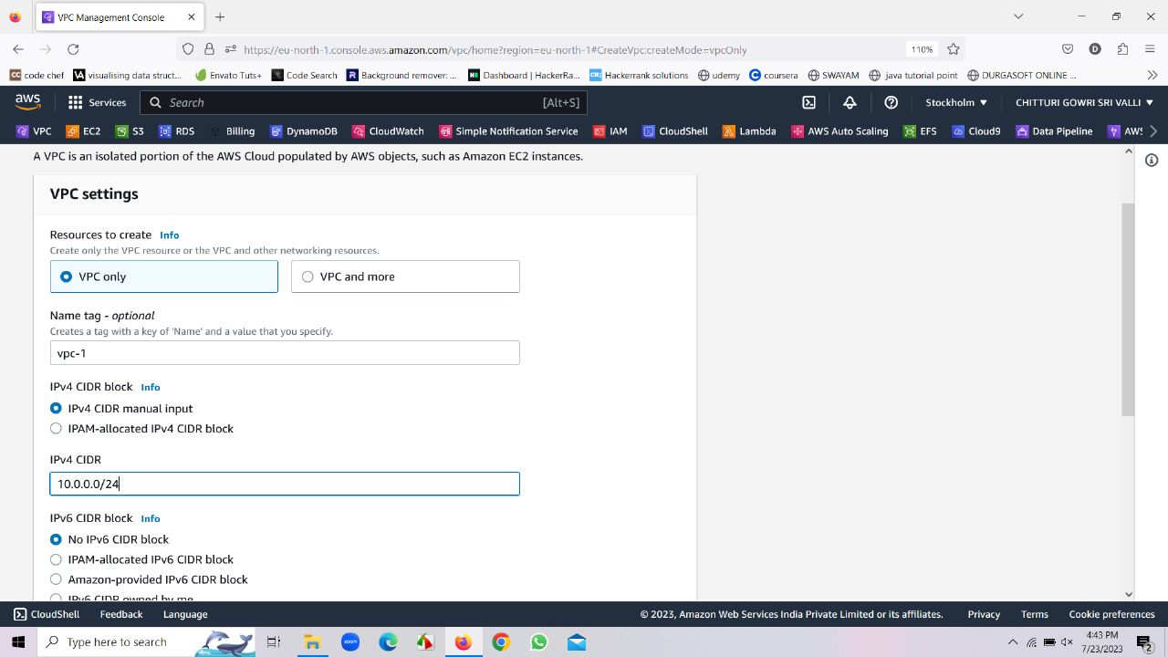

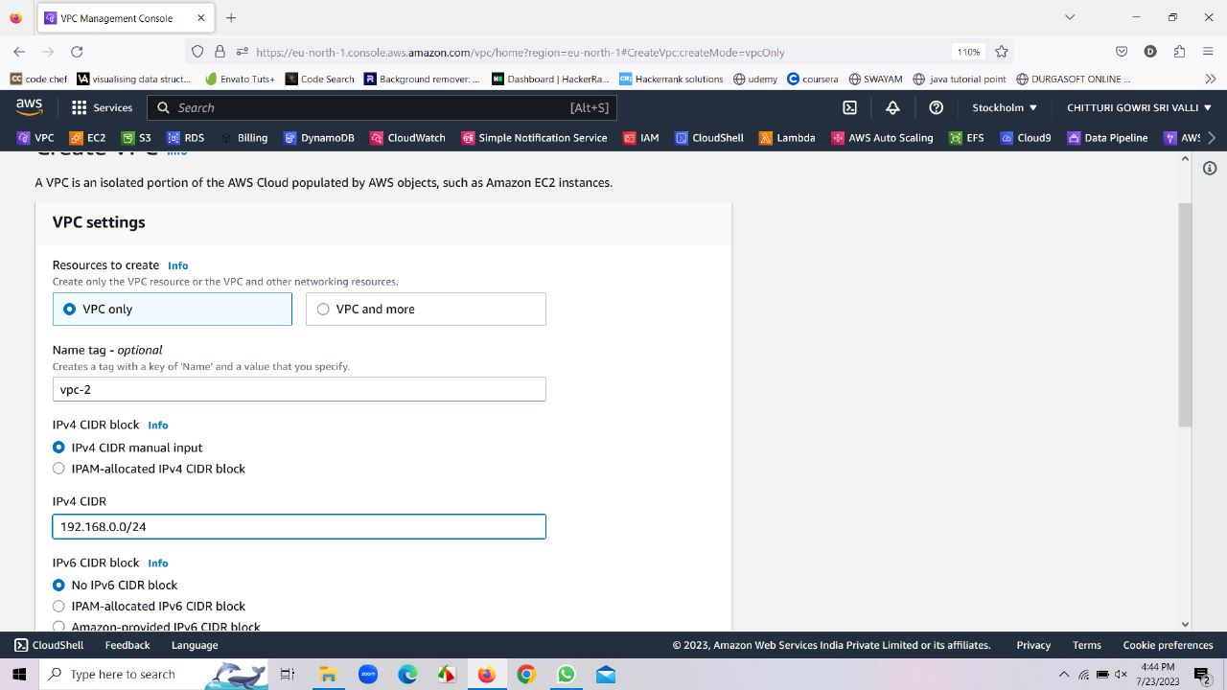

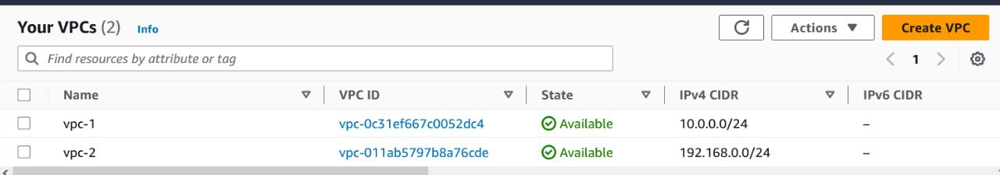

* Go to route table and edit the name of route table as rt1-vpc1 that is created along with vpc1.
* Go to route table and edit the name of route table as rt2-vpc2 that is created along with vpc2.

**Sub Service: Route Tables**

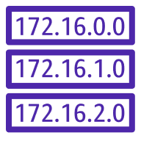

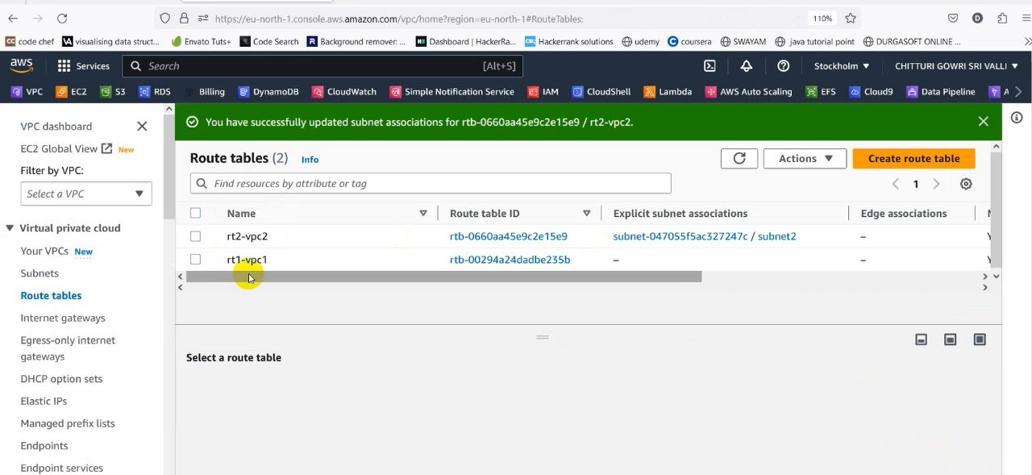

* Go to subnets and create a subnet and name it as subnet1. Select the availability zone as eu-north-1a, CIDR as 10.0.0.0/25 and select create subnet
* Similarly create an another subnet with name subnet2. Select the availability zone as eu-north-1a, CIDR as 192.168.0.0/25 and select create subnet

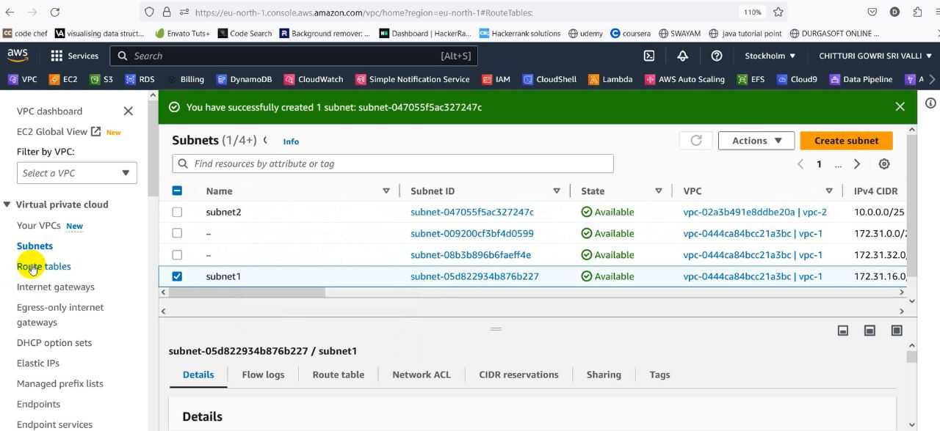

• Go to route tables, select the each route table, and go to subnet associations and select its subnet and click on save associations.

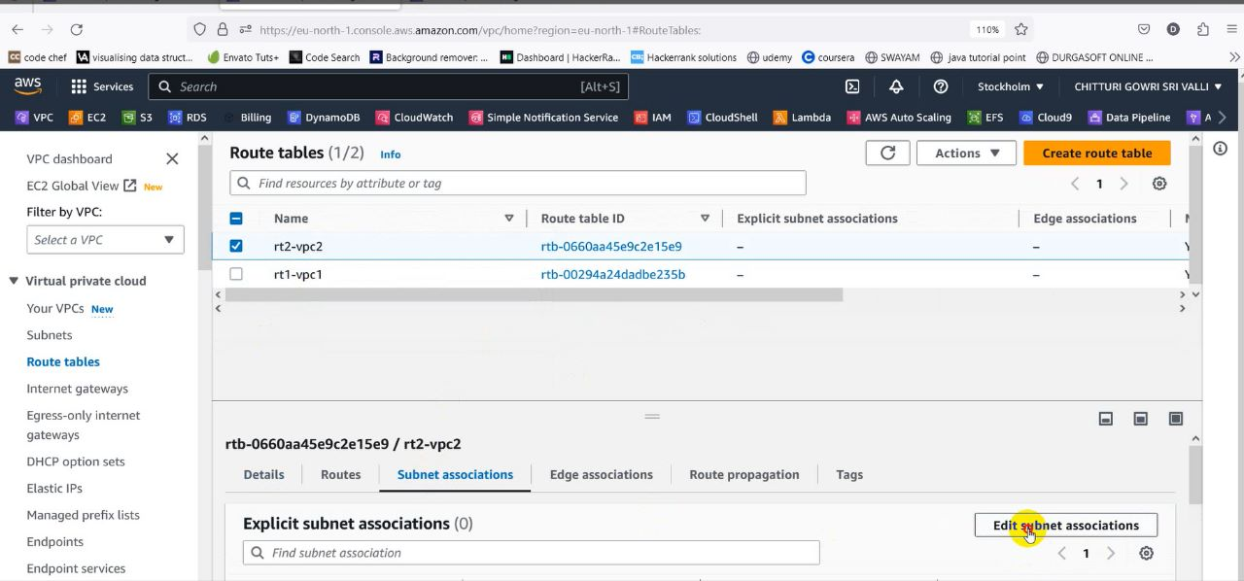

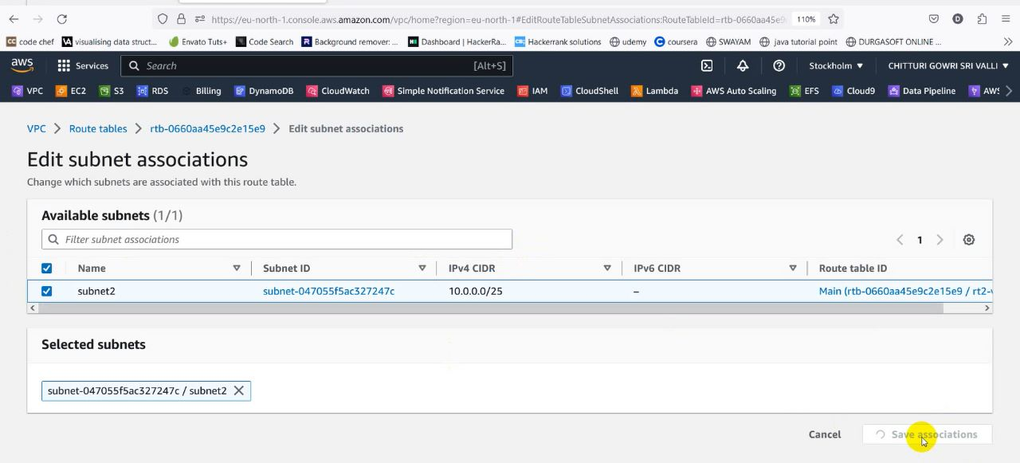

* Create an internet gateways with the name igw1-vpc1
* Create another internet gateway with the name igw2-vpc2

**Sub Service: Internet Gateway**



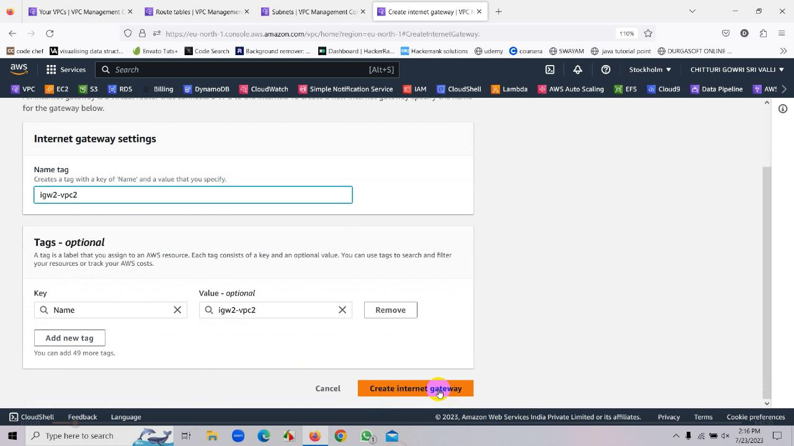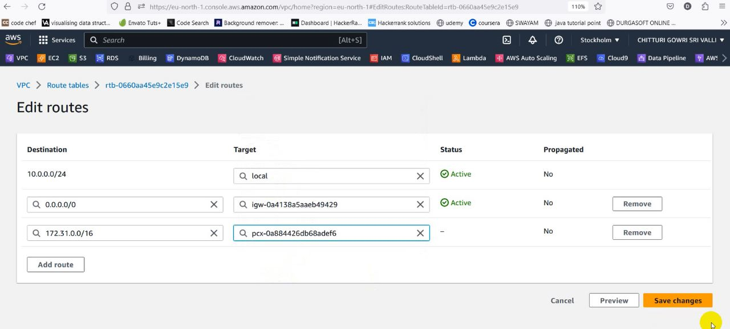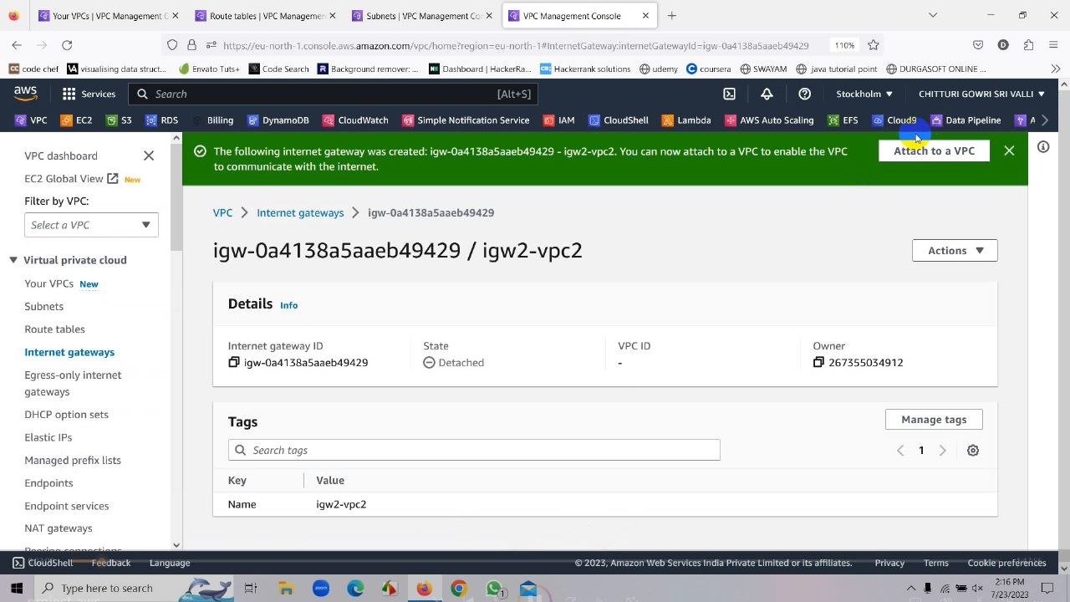

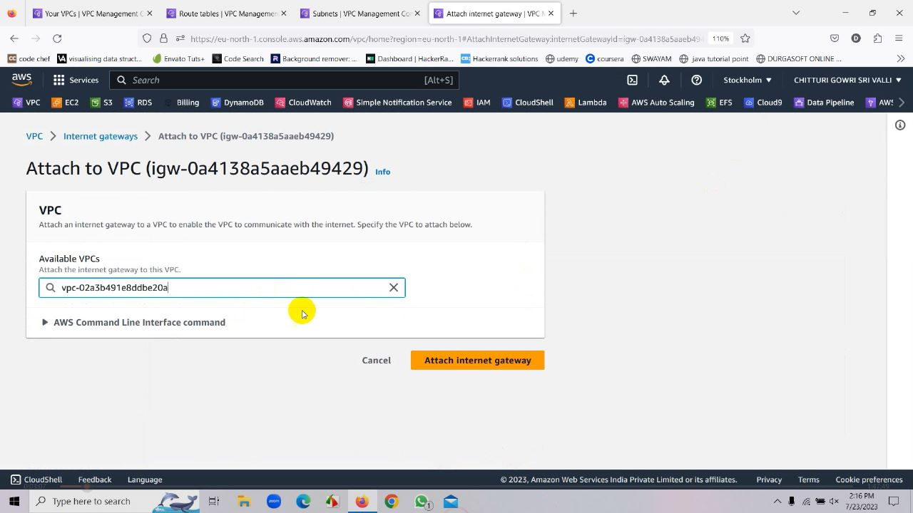

* Internet Gate Way is successfully attached to VPC
* Now go to route tables, select rt1-vpc1, click on edit routes, go to add routes, and add 0.0.0.0/0 at destination and select our internet gateway in destination and save it
* Now go to Peering Connection and give the name as vpc1-vpc2 and create a peering connection

**Sub Service: Peering Connection**



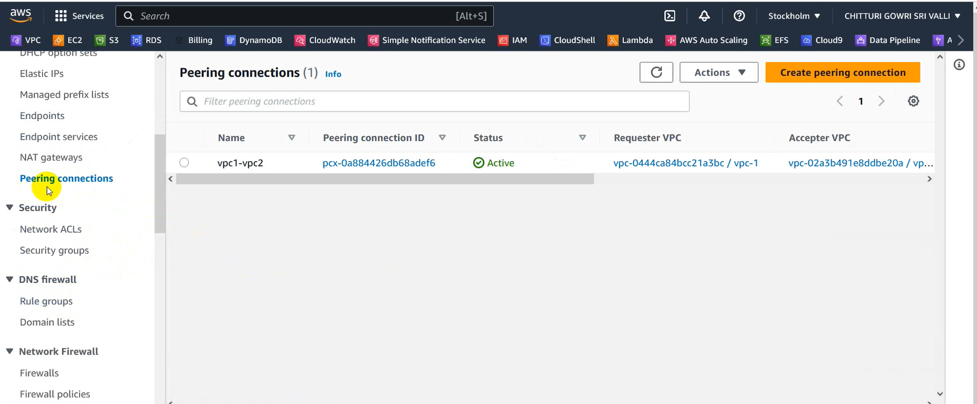

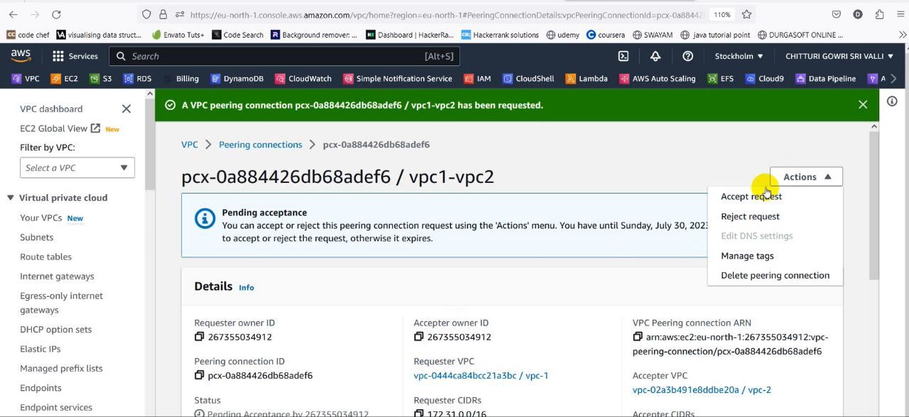

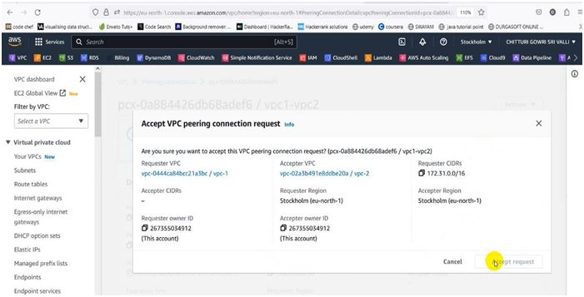

* Go to route tables, select rt1-vpc1,click on edit routes, go to add routes, and add 192.168.0.0/24 at destination and select our peering connection in destination and save it
* Execute the same process for rt2-vpc2 by adding 10.0.0.0/24 at destination and select our peering connection in destination and save it



**Service 2:EC2**



Click on Launch your instance

• Name your instance as vm1-vpc

• Select “Amazon Linux 2 AMI”.

• Instance type “t3. micro”.

• Select your existing key pair.

Select your custom VPC, public subnet and enable the auto-assign public IP.

•In the security group section, select availability zone as eu-north-1a.

• create a new security group, add security groups that supports SSH and all the traffic

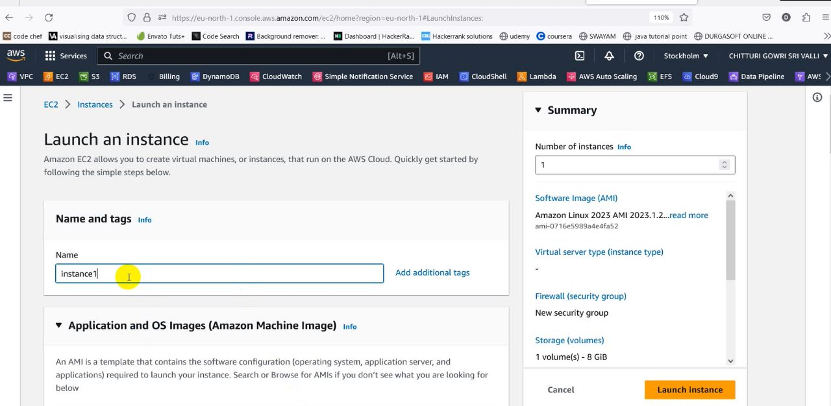

• Here we name the instance as “instance1”.

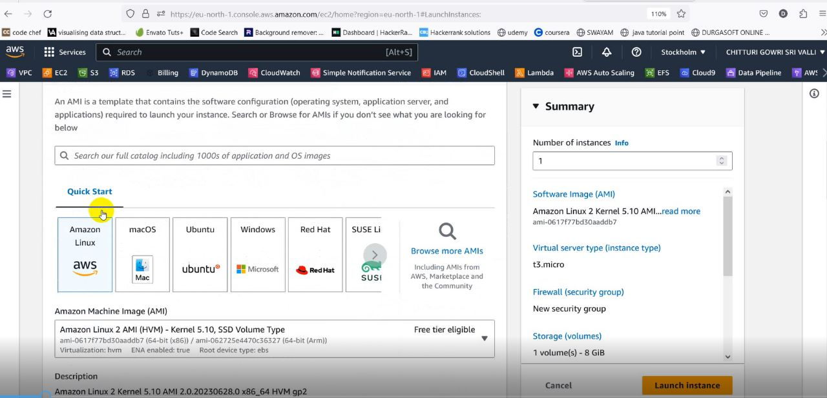

• We choose “Amazon Linux 2 AMI(HVM) – Kernel 5.10.SSD Volume Type in AMI

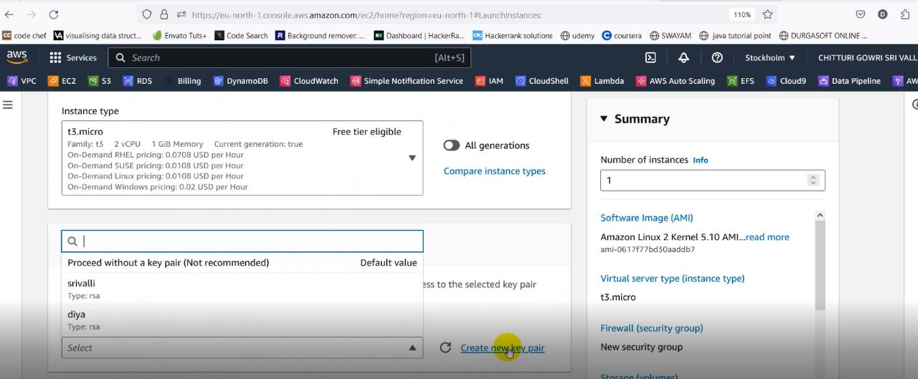

* Here we selected the key pair srivalli

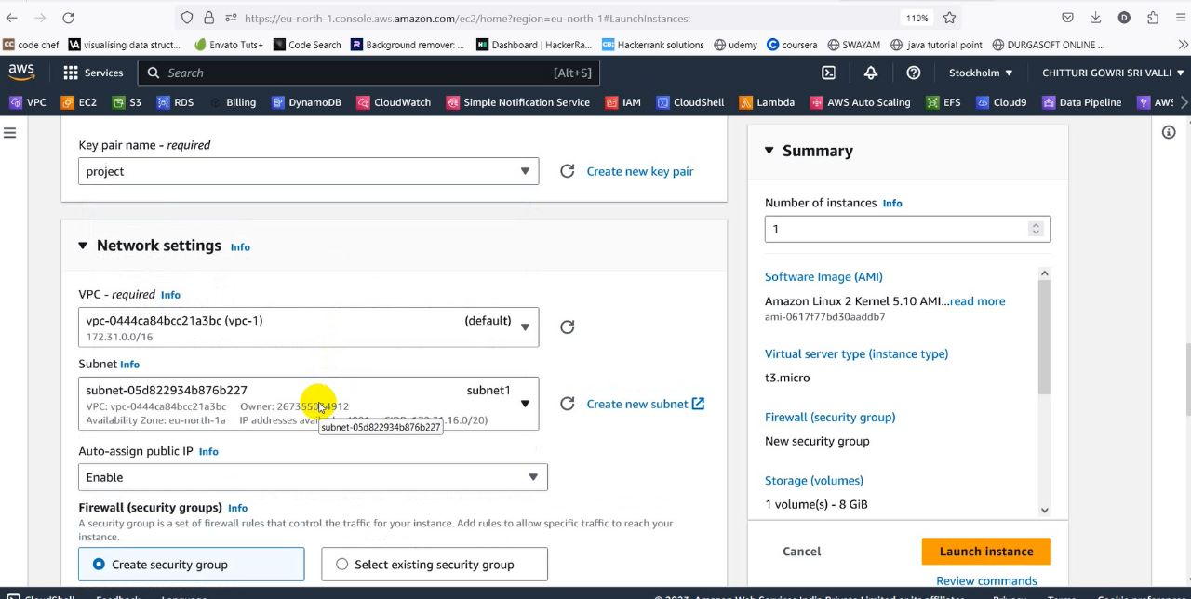

* We have selected the availability zone as eu-north-1a

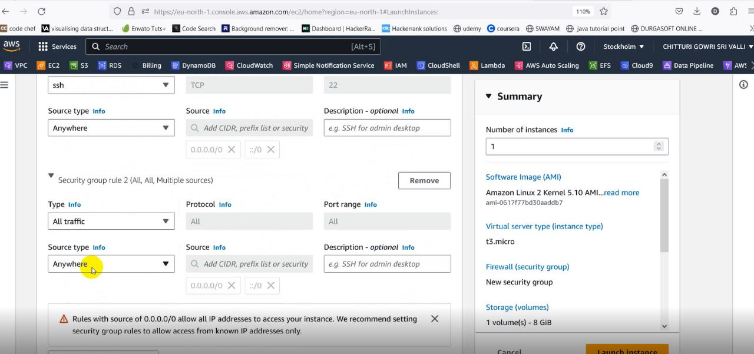

• Add “Type: All traffic”,” source type: Anywhere” in in bound security Group rules.

* In advanced details, click on the upload file and upload the following code

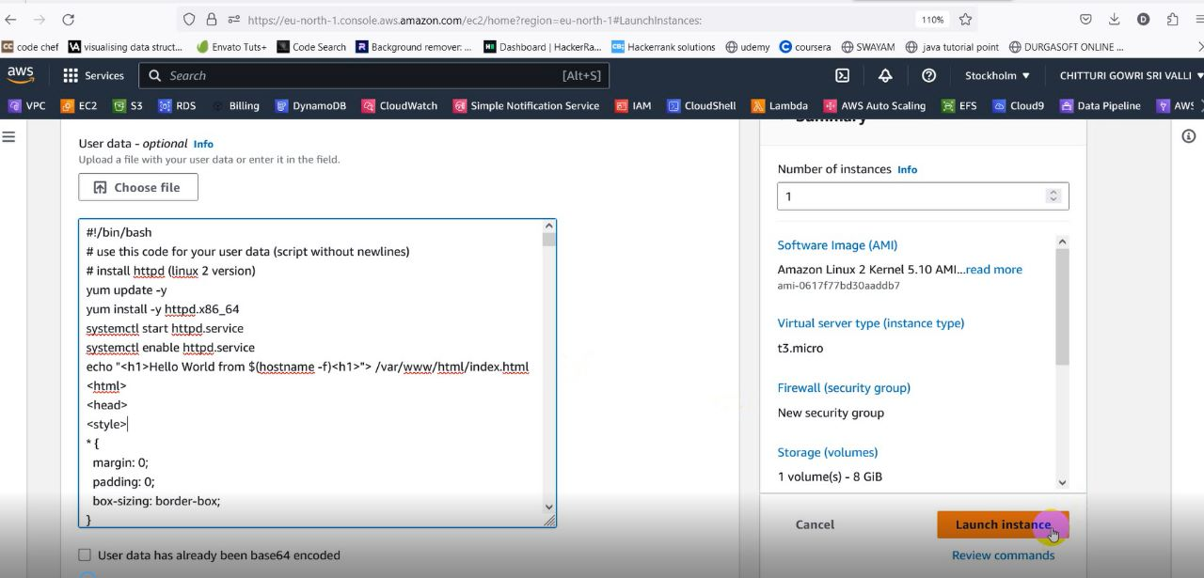

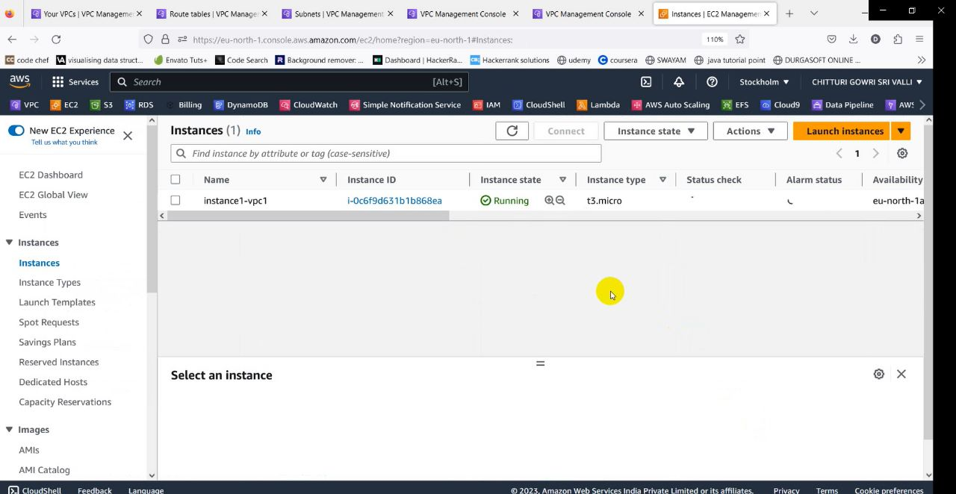

* Now “instance-1” is successfully launched.

**Sub Service: AMI**

• Select the instance-1

• Go to action.

• Go to image and templates.

• Click on create image, give image name, and create the image

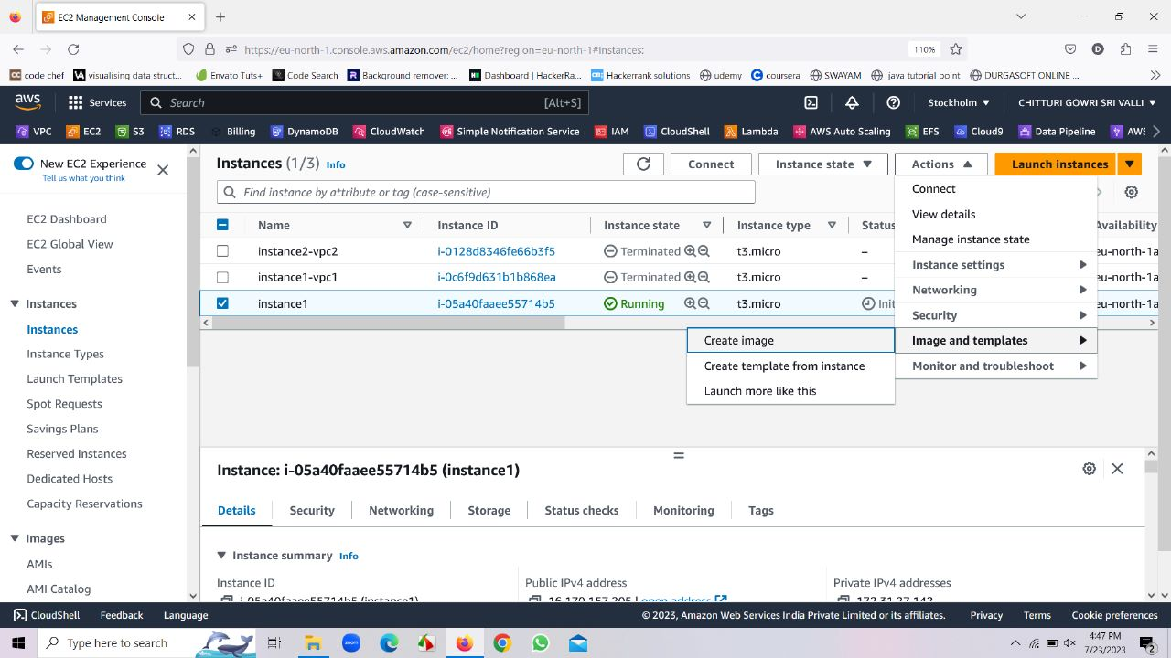

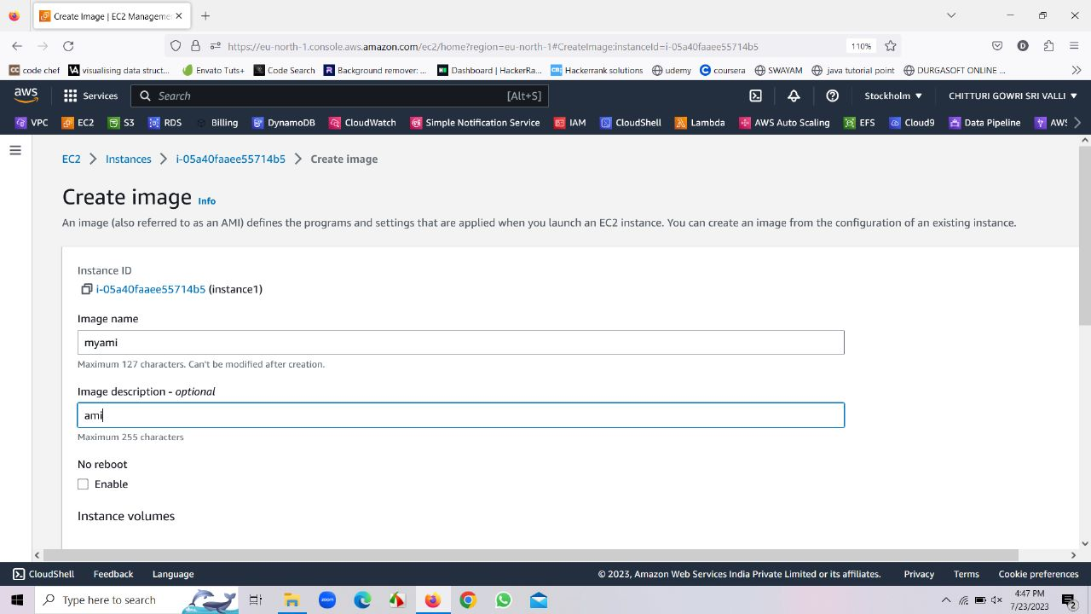

• After images have been created go to AMI, there we can find an AMI

. • Whenever an AMI is created a snapshot gets created along with i

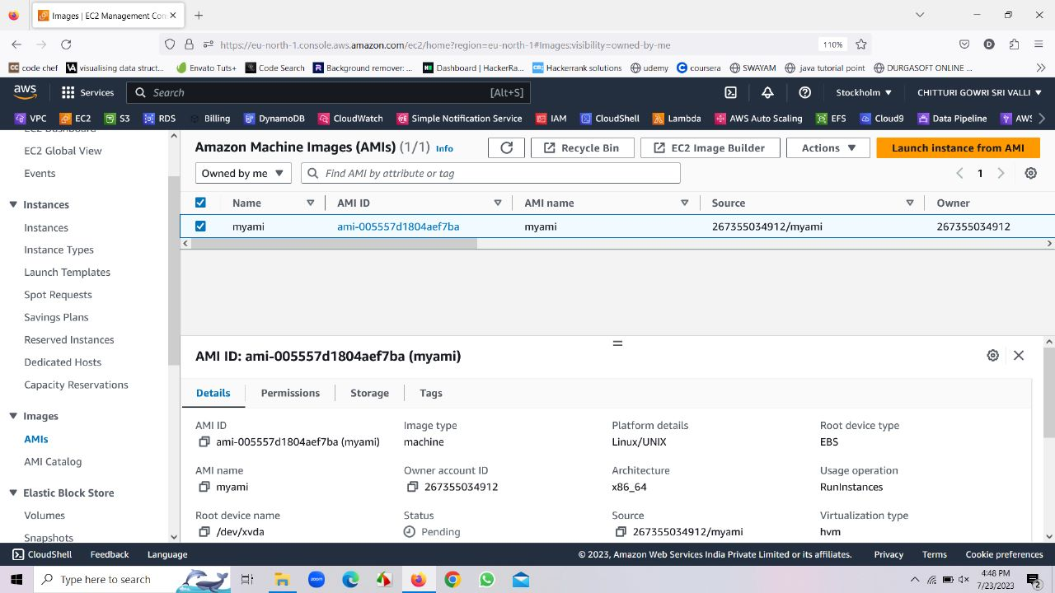

* Now click on launch instance from AMI to launch the instance-2

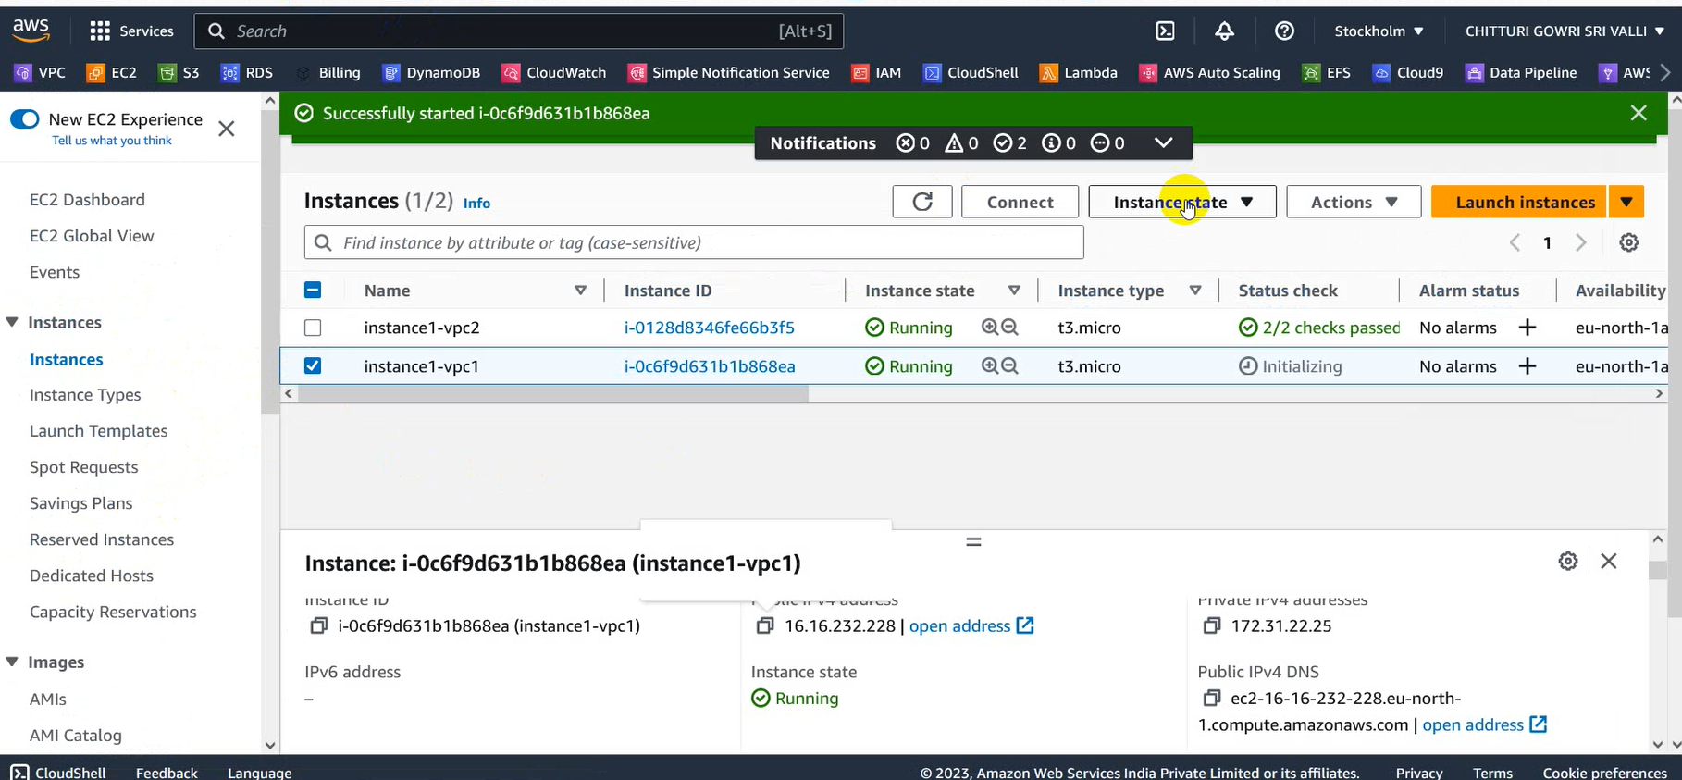

* Hence, in this way instance-2 can be launched

**Service 3: S3**



* Open S3 service and create 2 buckets with the names bucket1-vpc1,bucket2-vpc2 in the same region

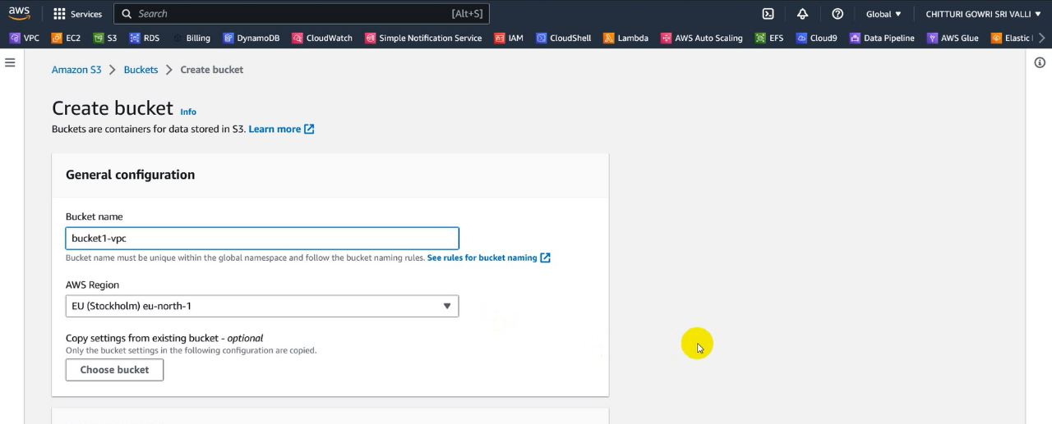

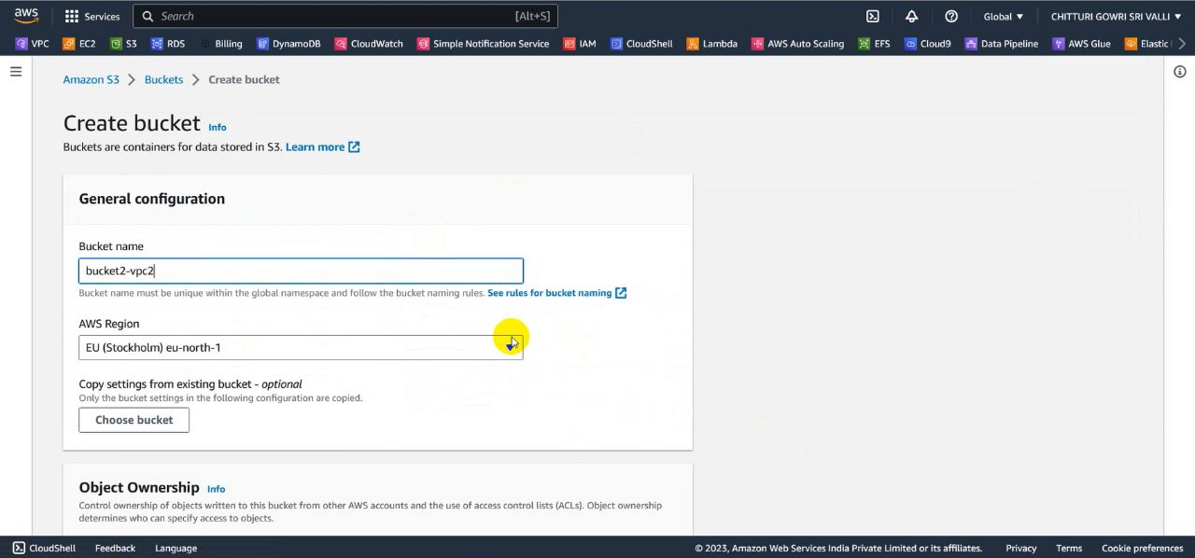

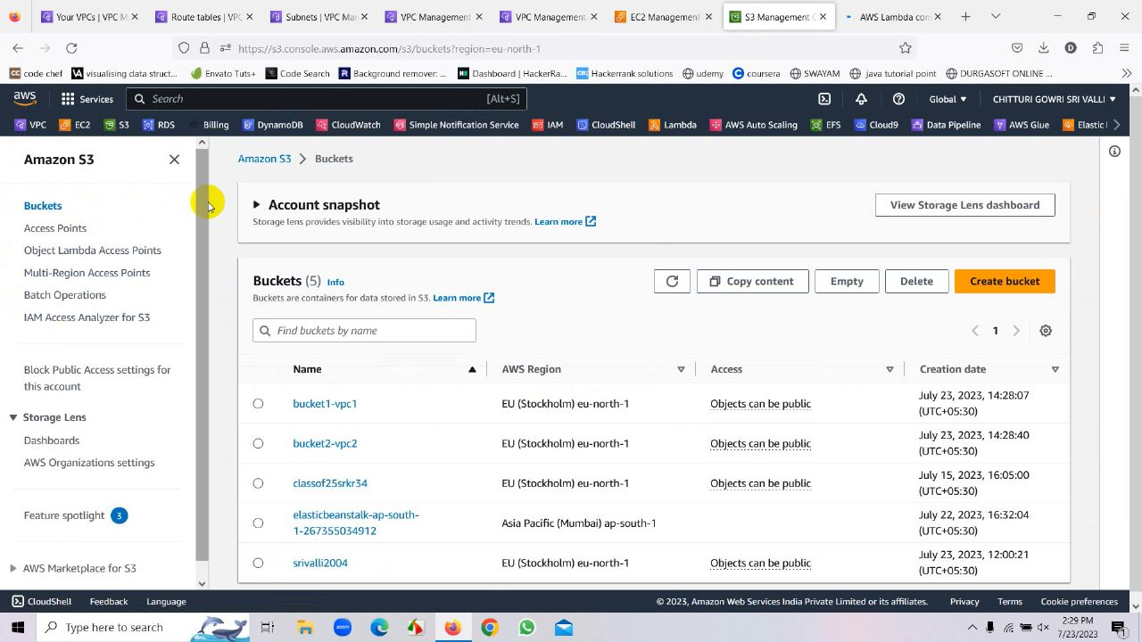

**Service 4: Lambda**



* Go to Lambda Serive
* Now Click on create a function
* Name the function as bucket1-bucket2
* Then the function can be created

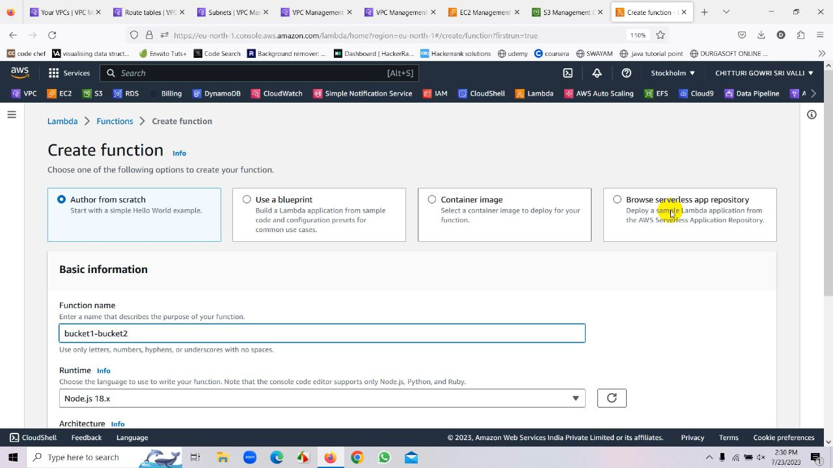

* After creation of the function we have to add the trigger to it

**Sub Service: Trigger**

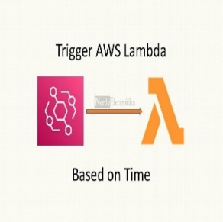

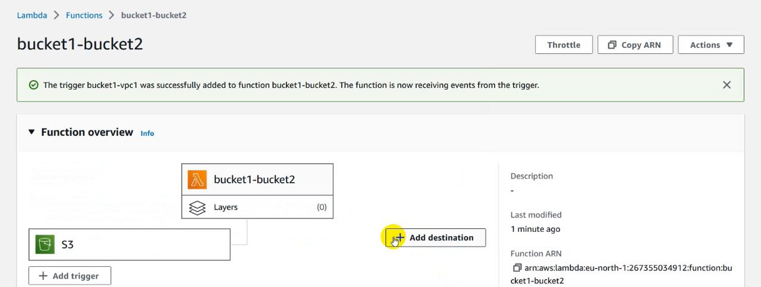

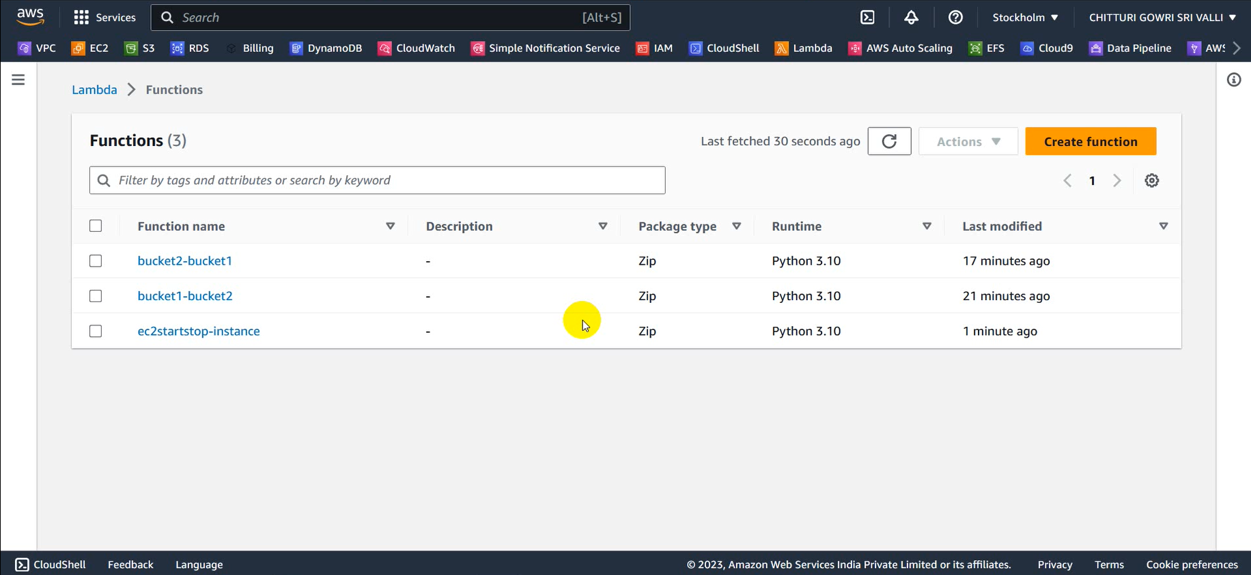

* Here we selected the s3 from the trigger.

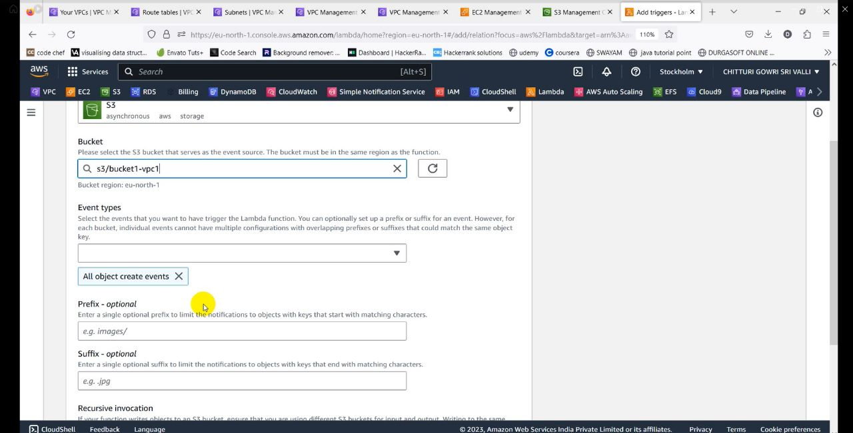

* Now we selected the bucket1-vpc1.Then the bucket can be added

**Sub Service: IAM Users**

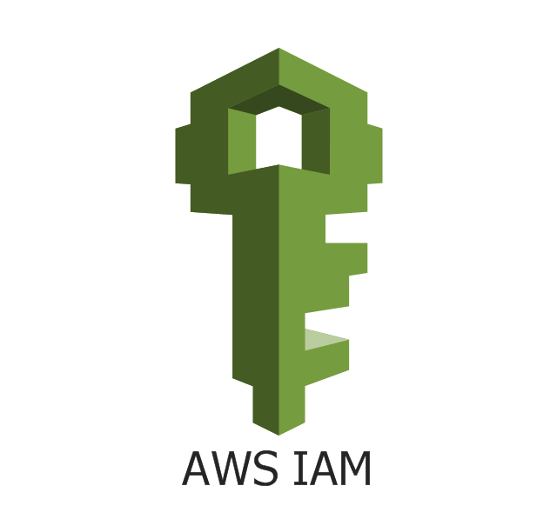

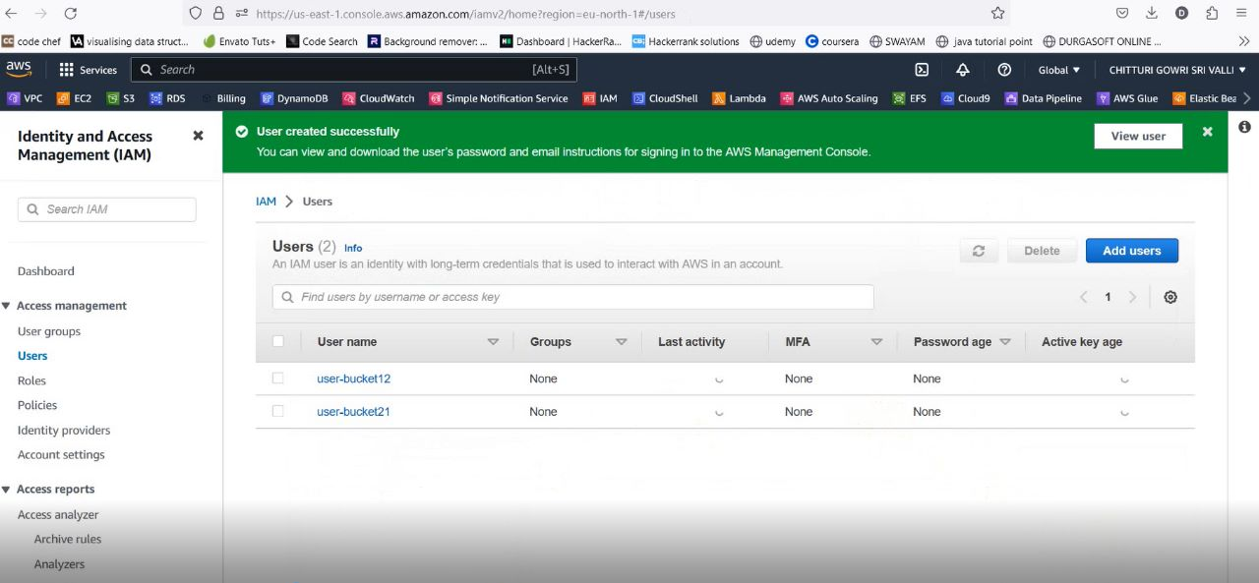

* In the similar way create another function with the name bucket2-bucket1
* Add the trigger to that function with the bucket2-vpc2
* After adding the trigger edit the lambda function with code by changing the bucket name ,Access Key , Secret Key and click on deploy
* Here Access Key and Secret Key are extracted from the IAM user.

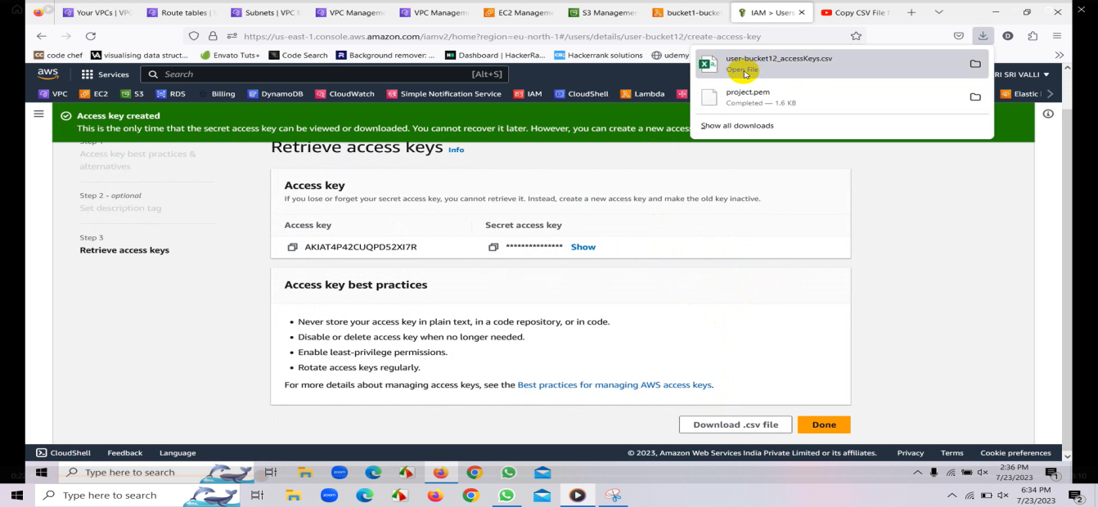

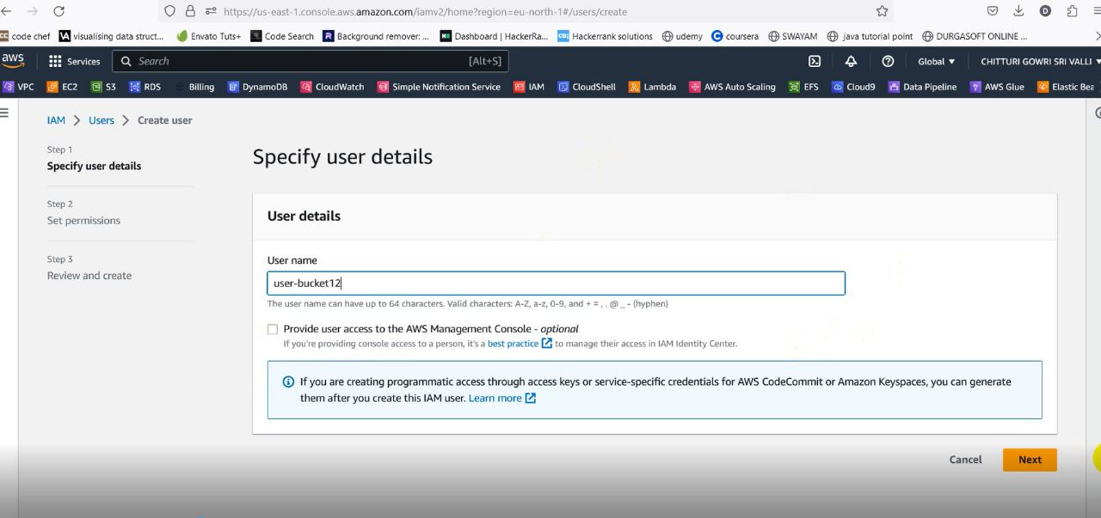

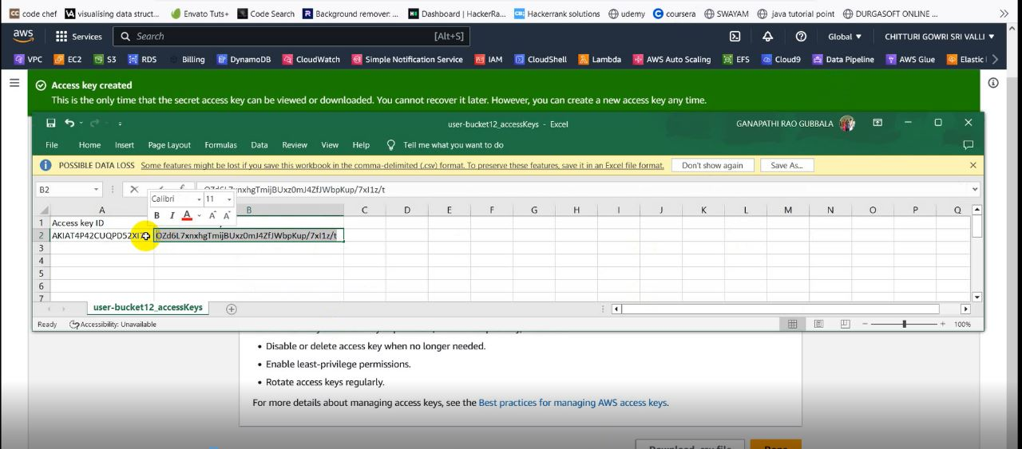

* For this we create an IAM user which is succeeded by a CSV file containing Access Key and Secret Key using these we design a code and deploy it

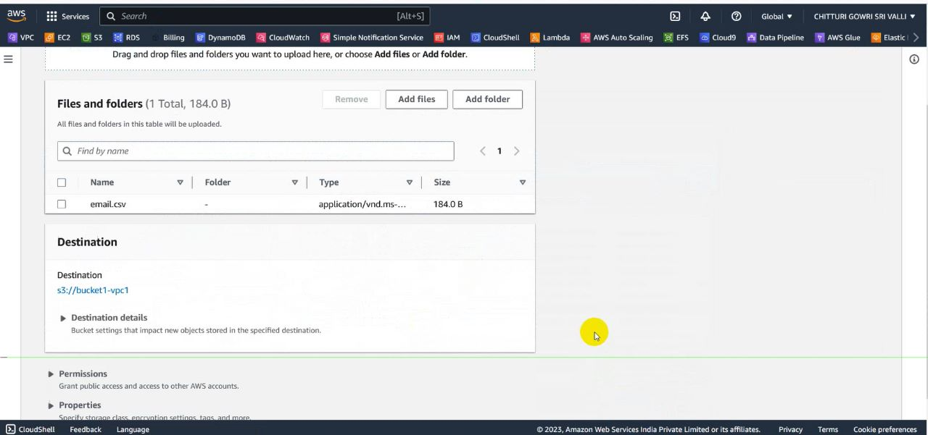

* Now our code is successfully deployed and now if we upload data in one bucket from external tool it will be reflected in another bucket.
* This is transfer of data from source bucket(bucket1-vpc1 or bucket2-vpc2) to destination bucket(bucket2-vpc2 or bucket1-vpc1)

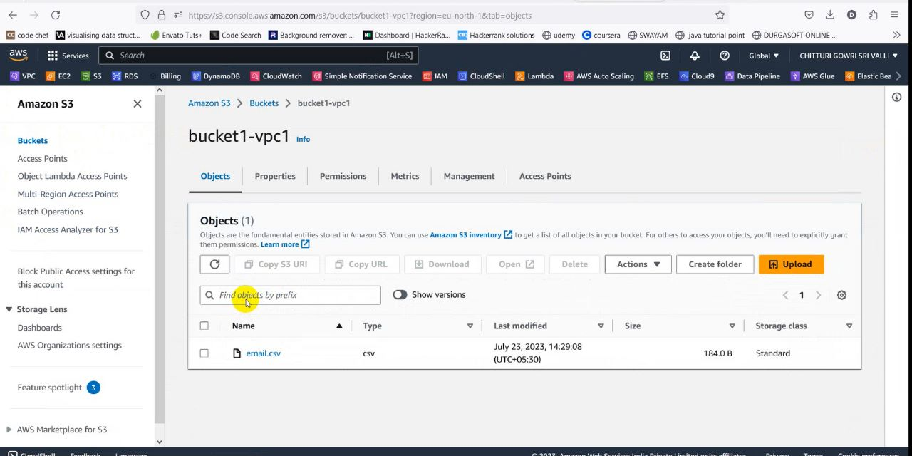

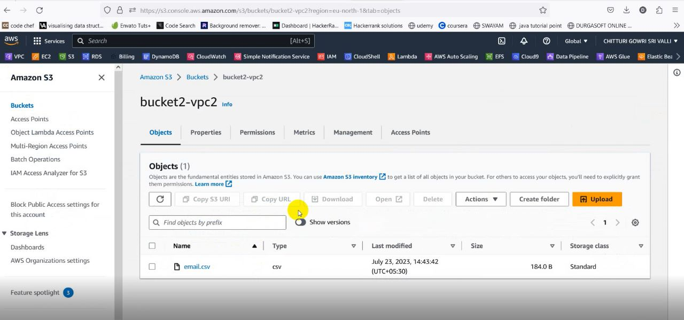

Lambda used for EC2:

* We can stop, start, terminate the instance by creating a function in lambda.
* Go to lambda and create function named ec2startstop-func.

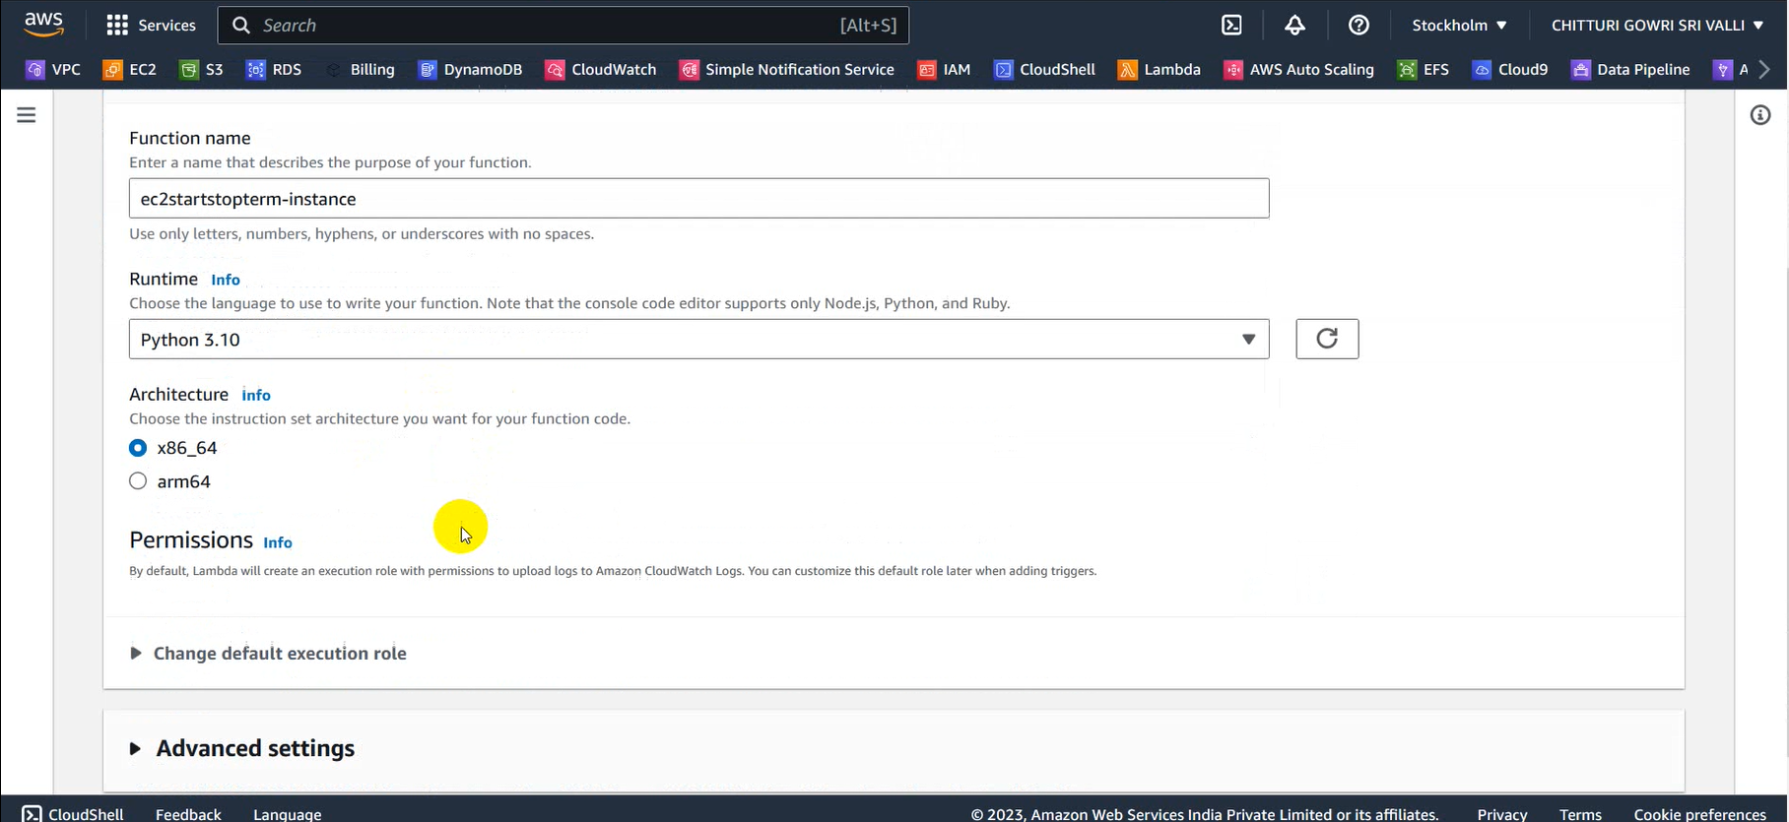

* Now go to code and add the stop instance code by giving our instance ID and region which we want to stop

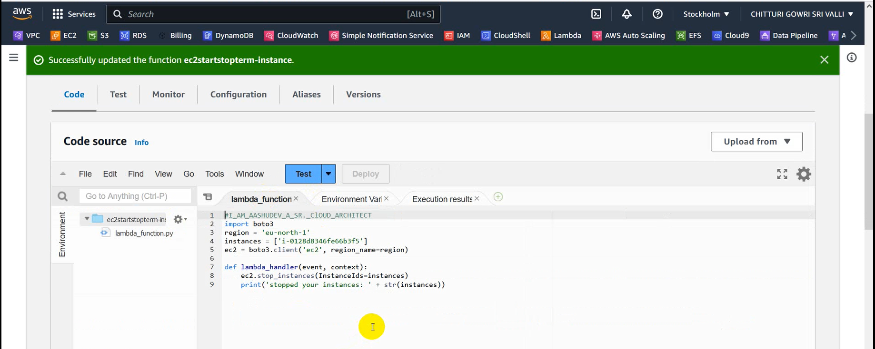

* In this way we can edit the code to stop, start and terminate the instance.
* After giving the code deploy the code and test the code.
* Now check the instance we can see that instance gets to stop, stop and terminate after testing the particular code

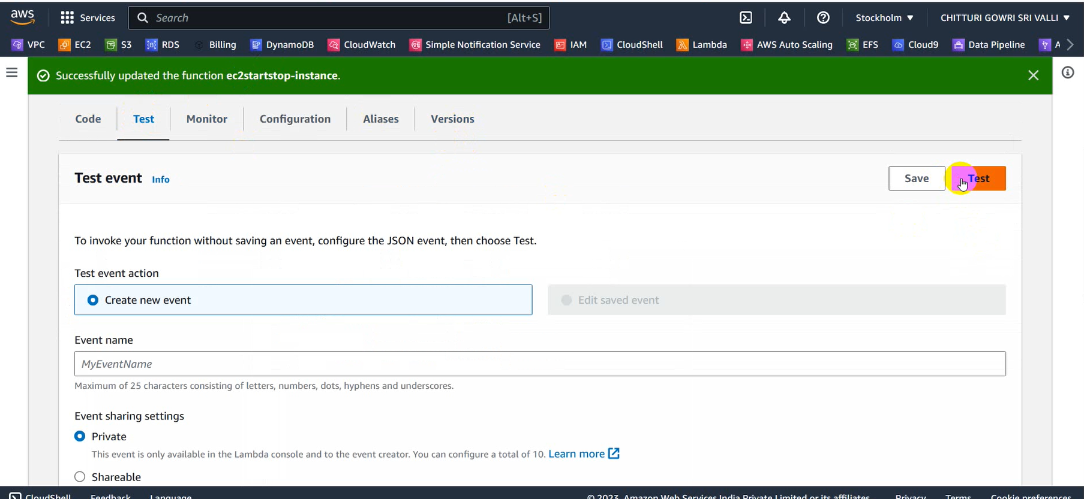

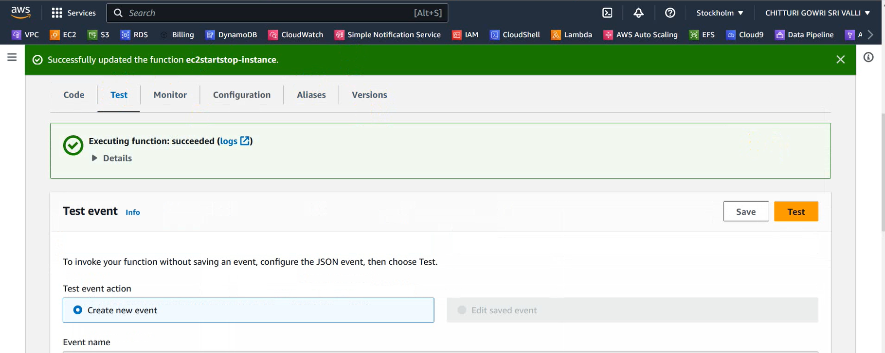

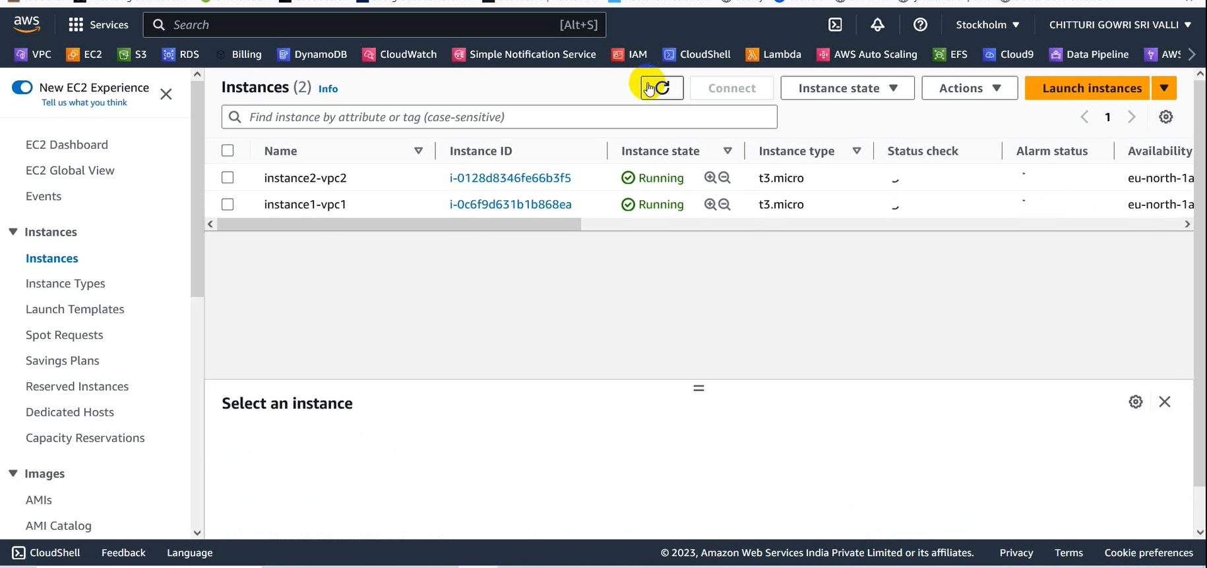

**Service 5: DynamoDB**



* Now we import data from S3 to DynamoDB
* We use a sub service called import from S3 using this we import data from S3 by eliminating duplicates

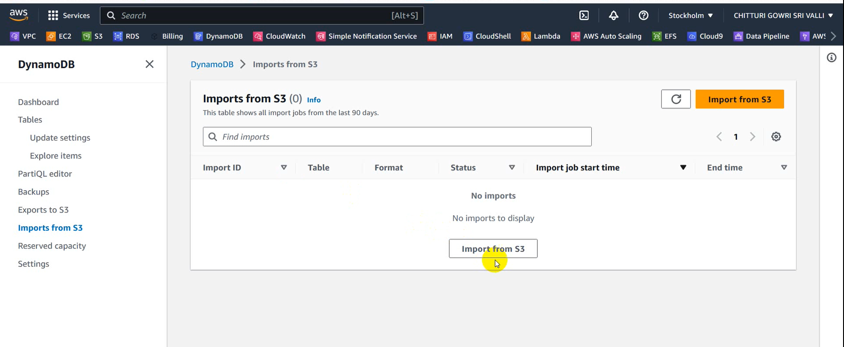

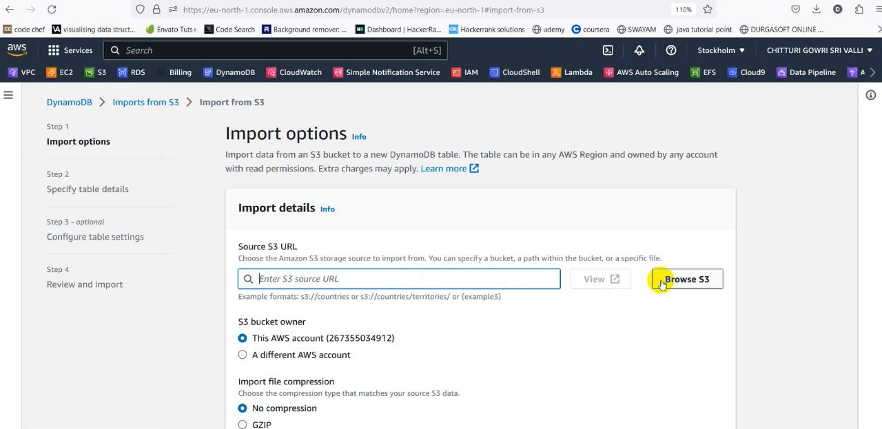

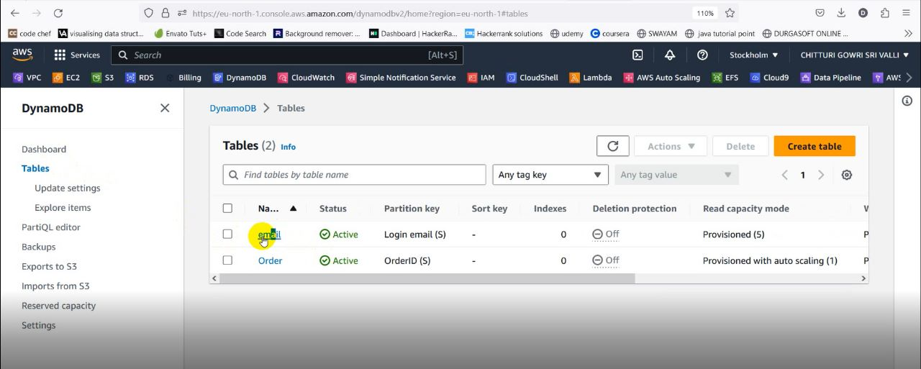

* As it is shown in the above figure the data is imported from the S3 bucket

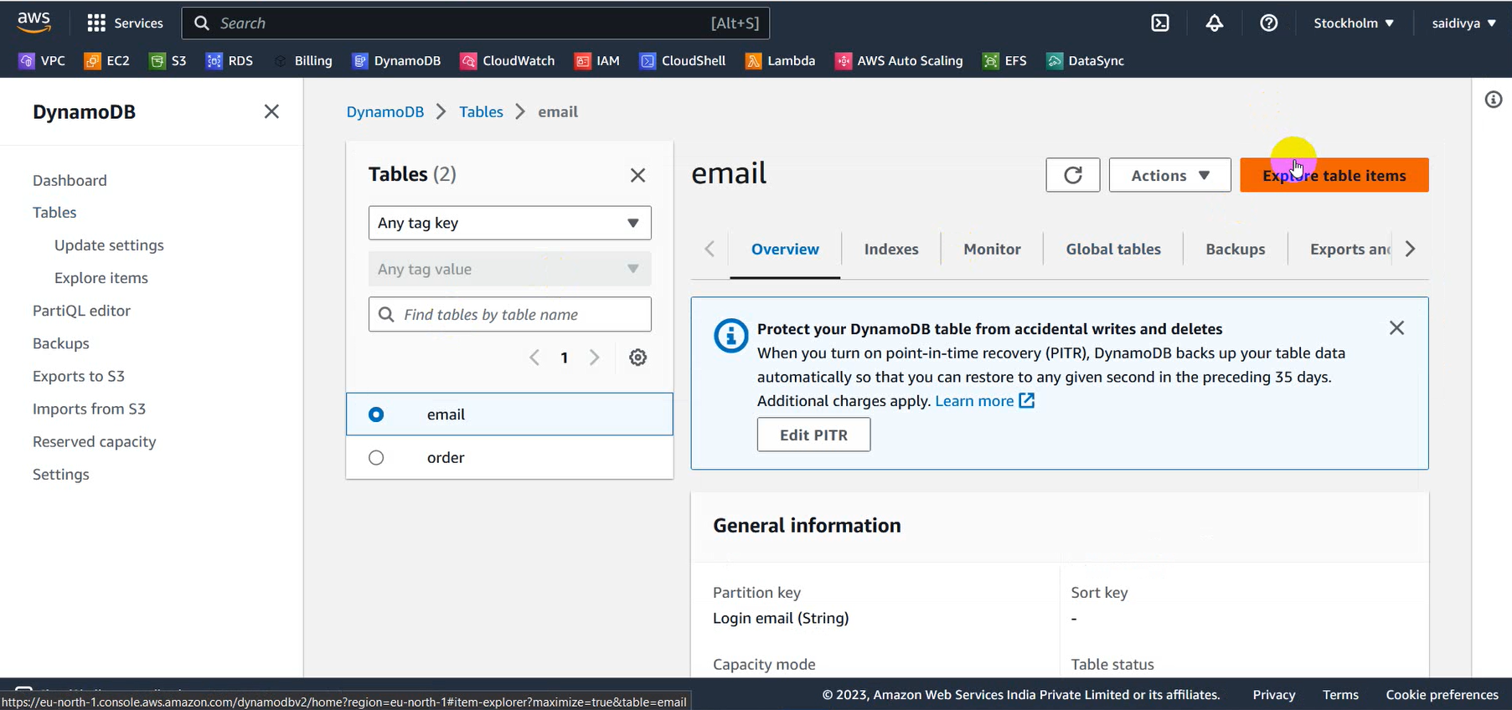

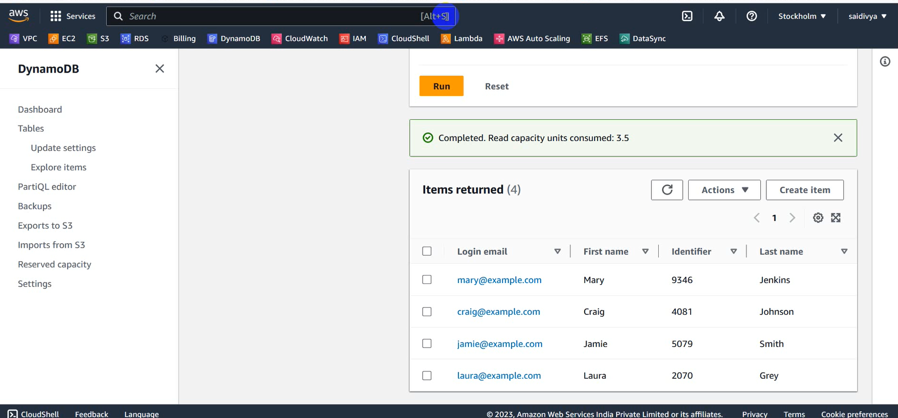

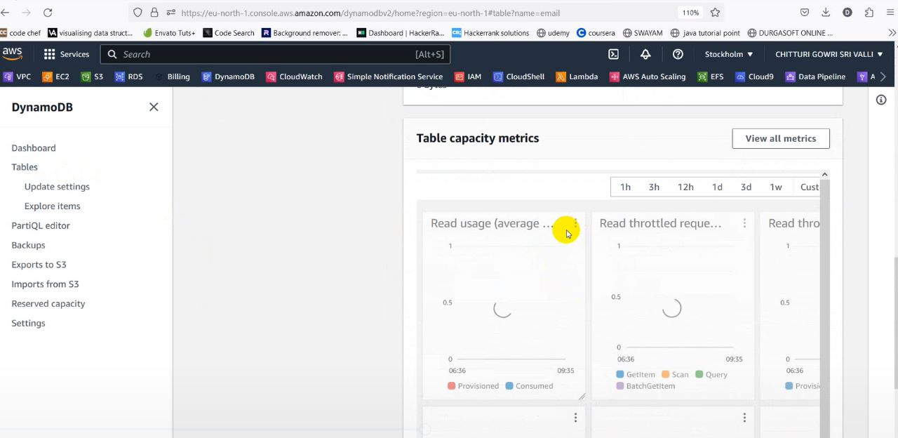

* After this we access the details of the imported data then we redirect to the table capacity metrics.
* Here we enlarge the read usage and we will be redirected to cloud watch.

**Service 6: CloudWatch**



* In Cloud Watch we view Metrics and now move to Graphed Metrics.
* Here we create an alarm using the bell icon in Provisioned Read.

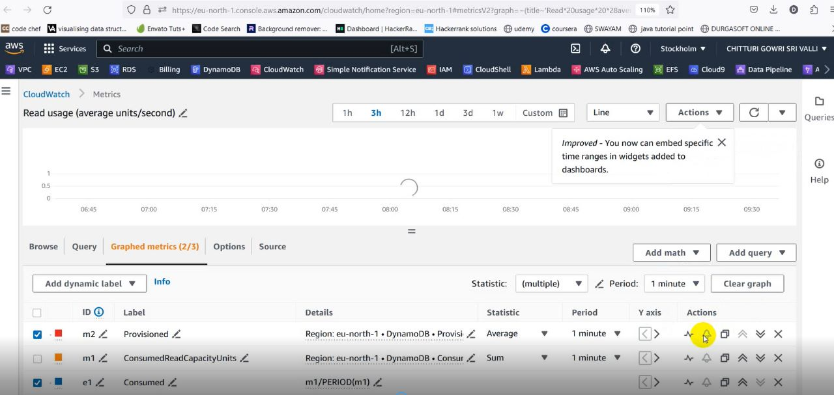

* Now we Specify our metric conditions.

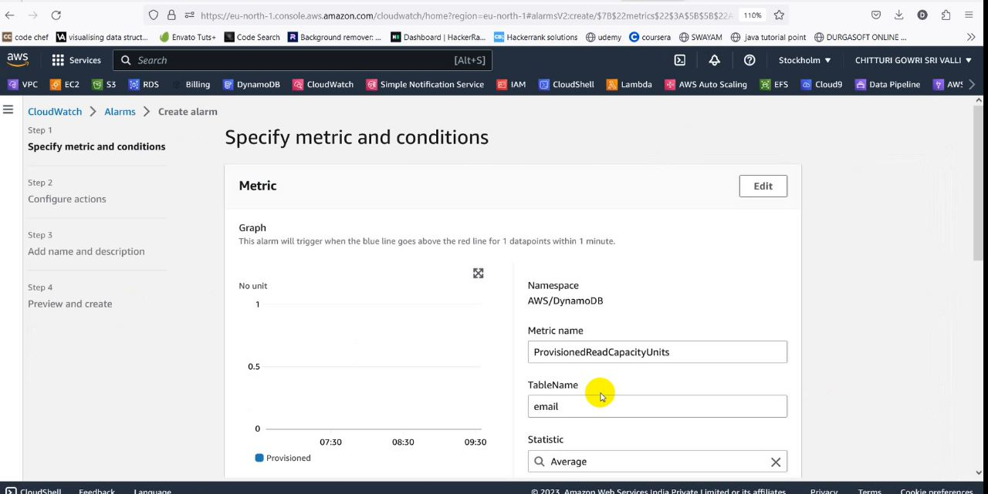

* Now here we provide a Threshold of our comfort.
* Now we will create an alarm topic and we will send request to emails.
* After this we view the subscribers in SNS.

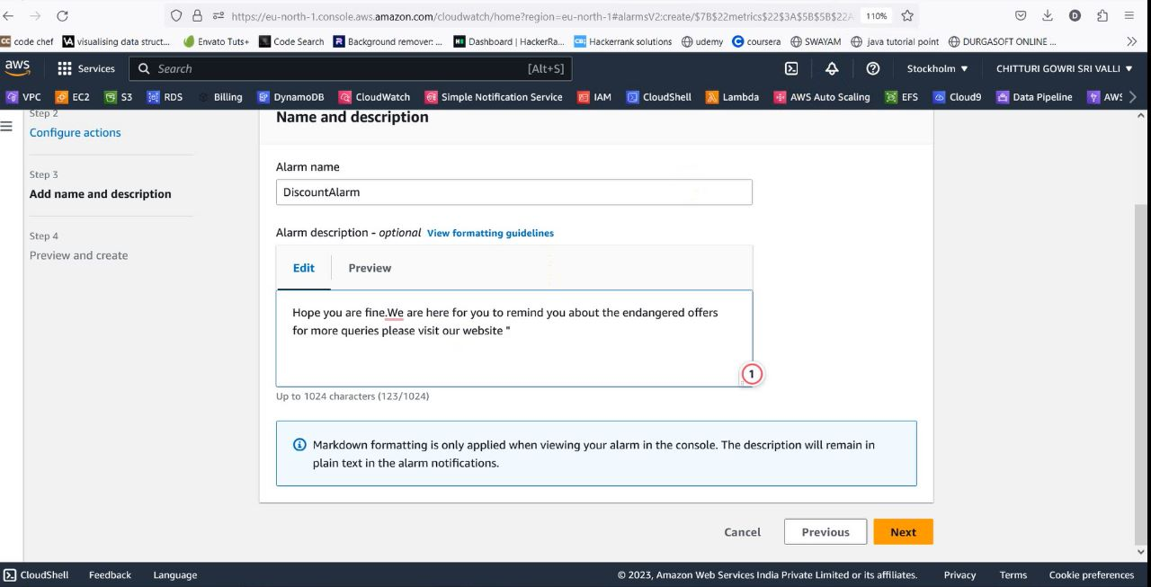

* Now if our threshold limit is not crossed an email will be sent to the subscriber intimating some issue.

**Service 7: Simple Notification Service (SNS)**

****Now we view or Alarm topic in SNS console.

* Here we view our subscribers who subscribed for our alarm topic for which we have sent.

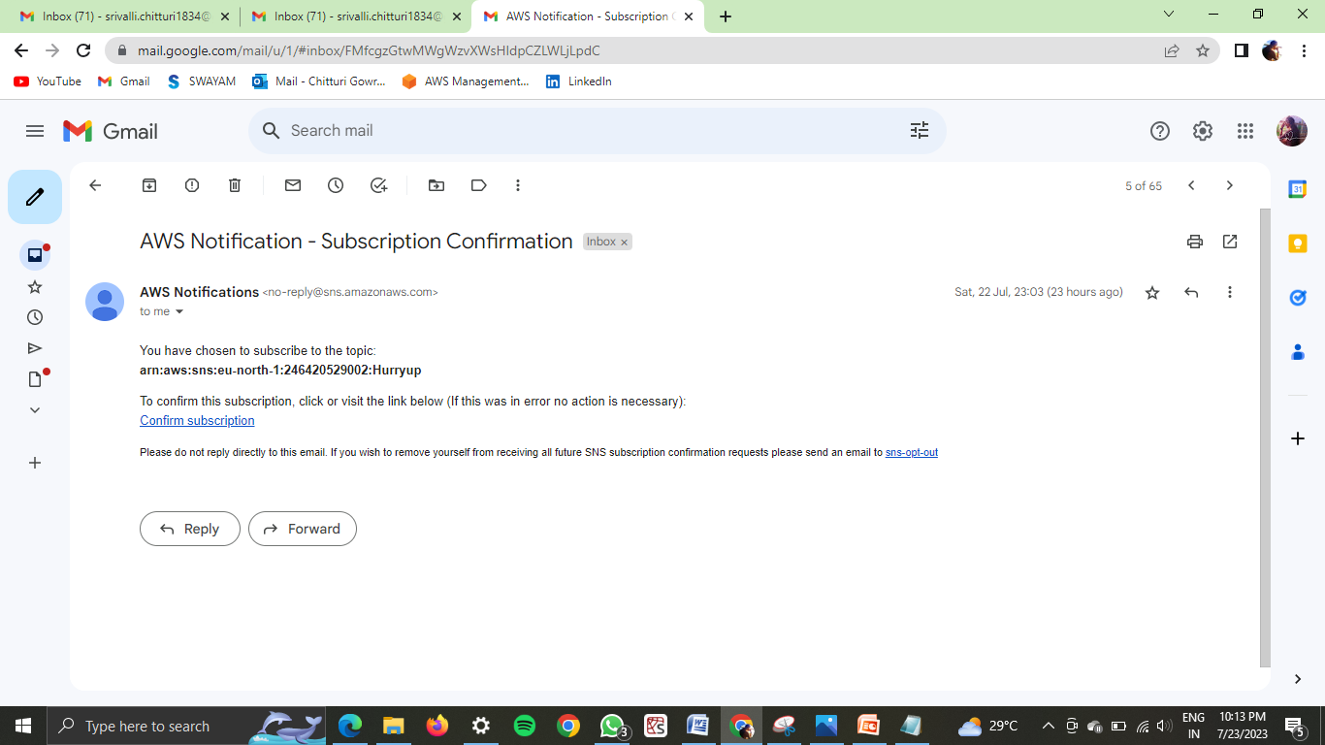

* Now we can publish a message to our subscribers.

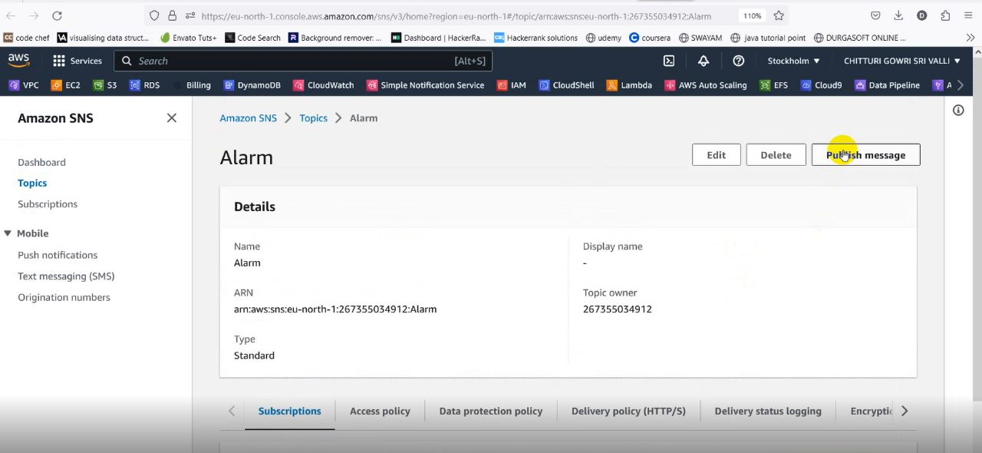

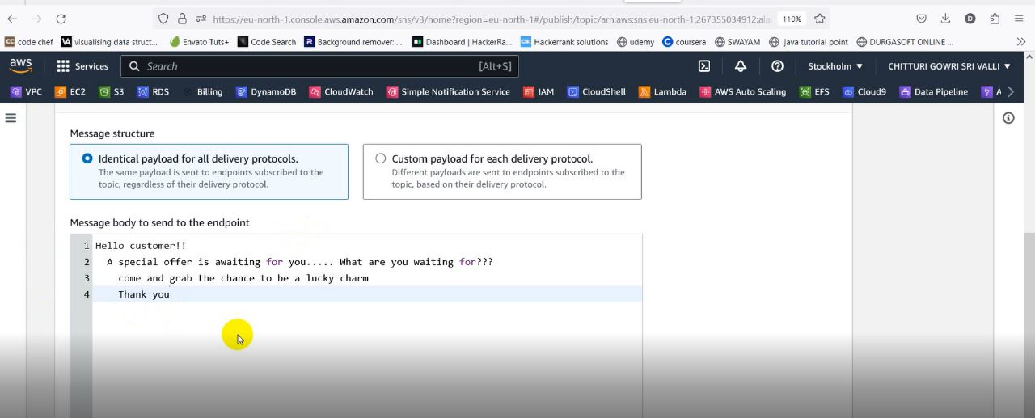

* Now our message is published to our subscriber.

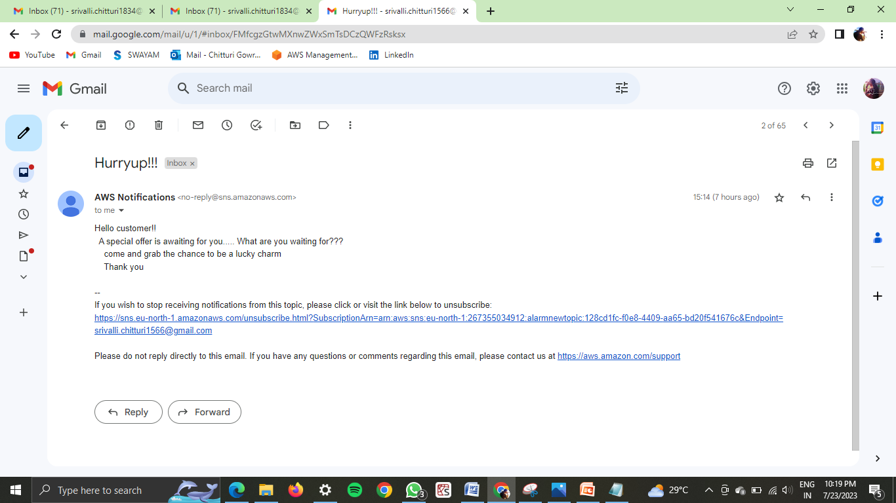

**Service 8: ELB**

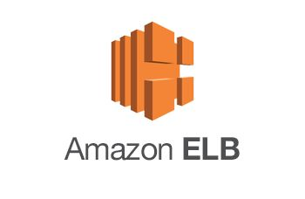

* Create a load balancer in EC2
* Name the load balancer as bootstra

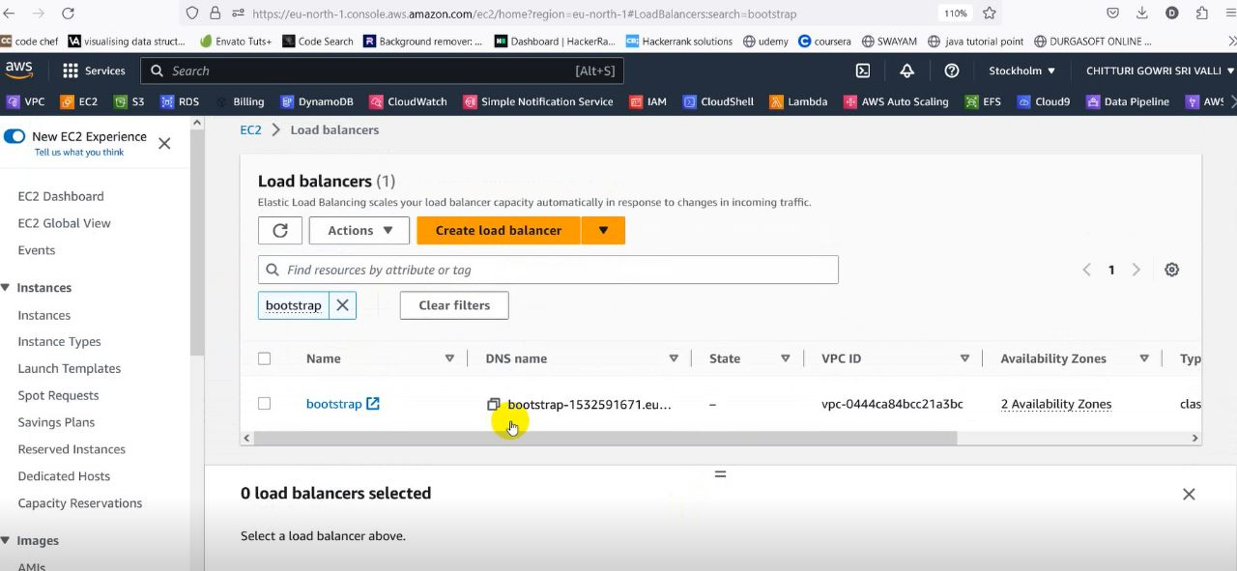

* Click on the load balancer and check the status of instance is in-service or not
* If the status of the instance is still Out of service then we have to edit the inbound rules of the security group

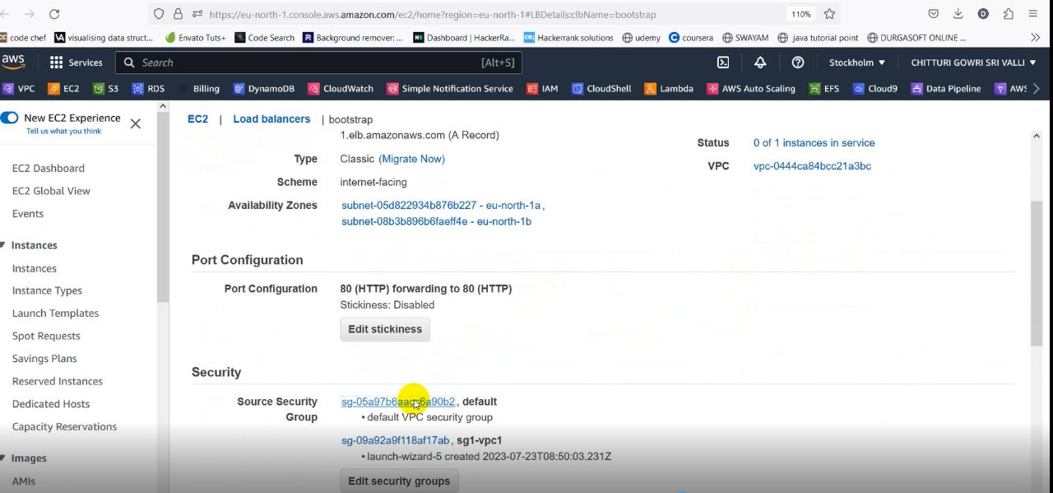

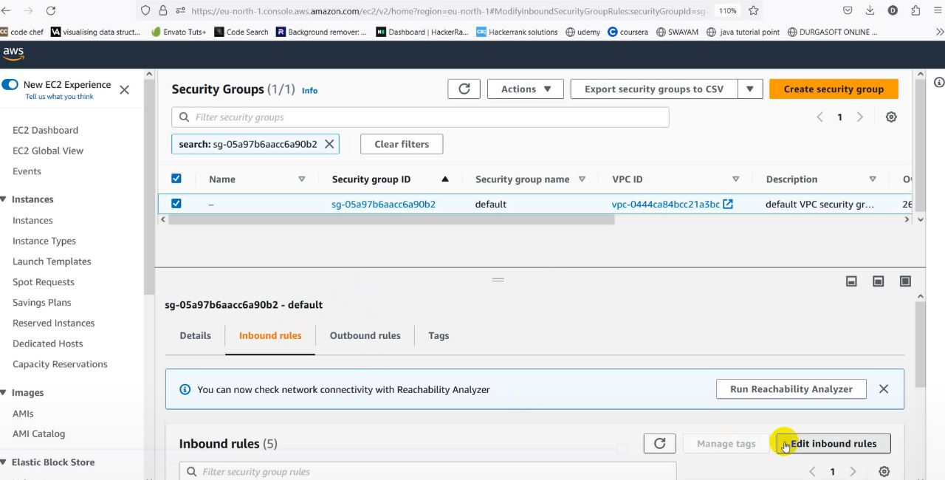

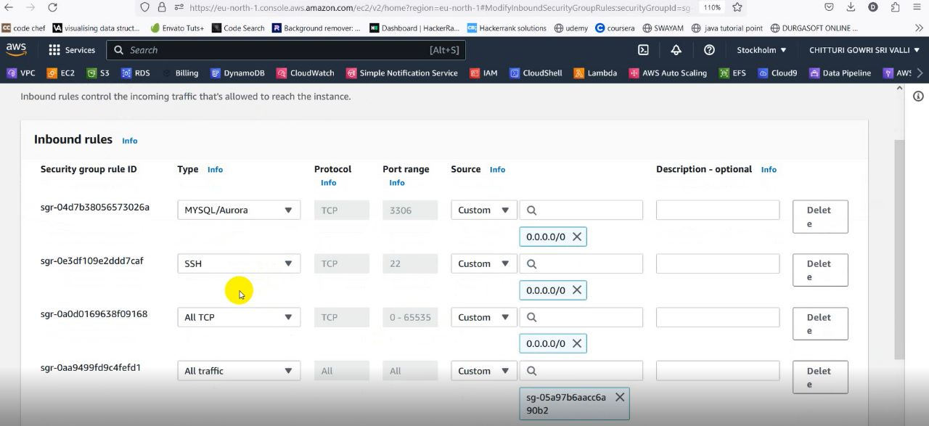

* After editing the inbound rules of security group, again check the status of the instance
* Here we got the instance in in service

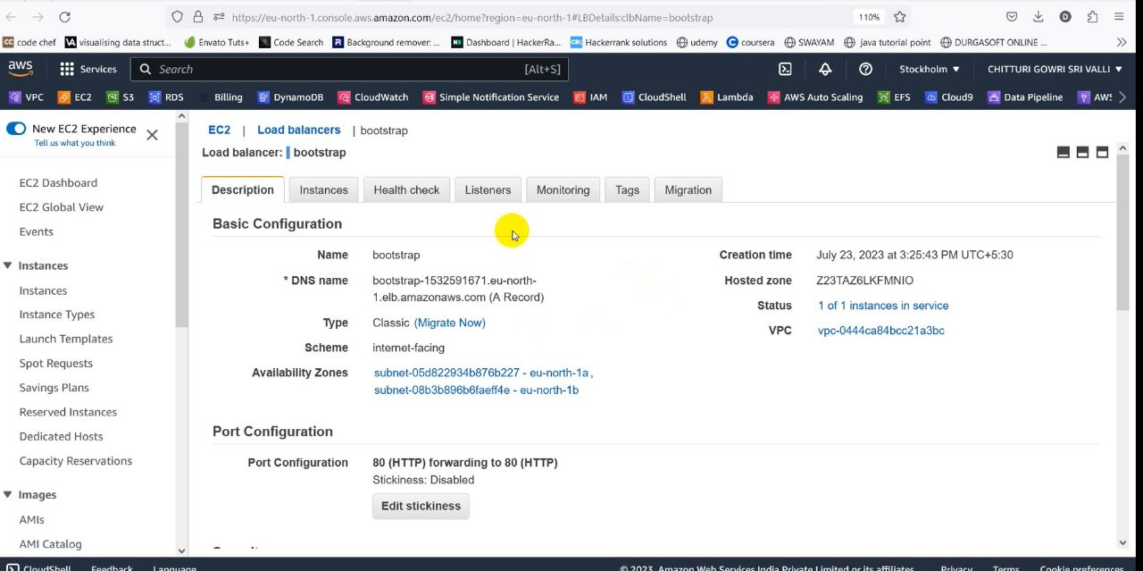

**Sub** **Service: Boot Strapping**



* While we creating the instance1 , we have uploaded a file in the advanced details which is used to create a website
* From the previous step,as we get the status of the instance is inservice,we have to copy the public Ip address of instance1 and paste it in a new tab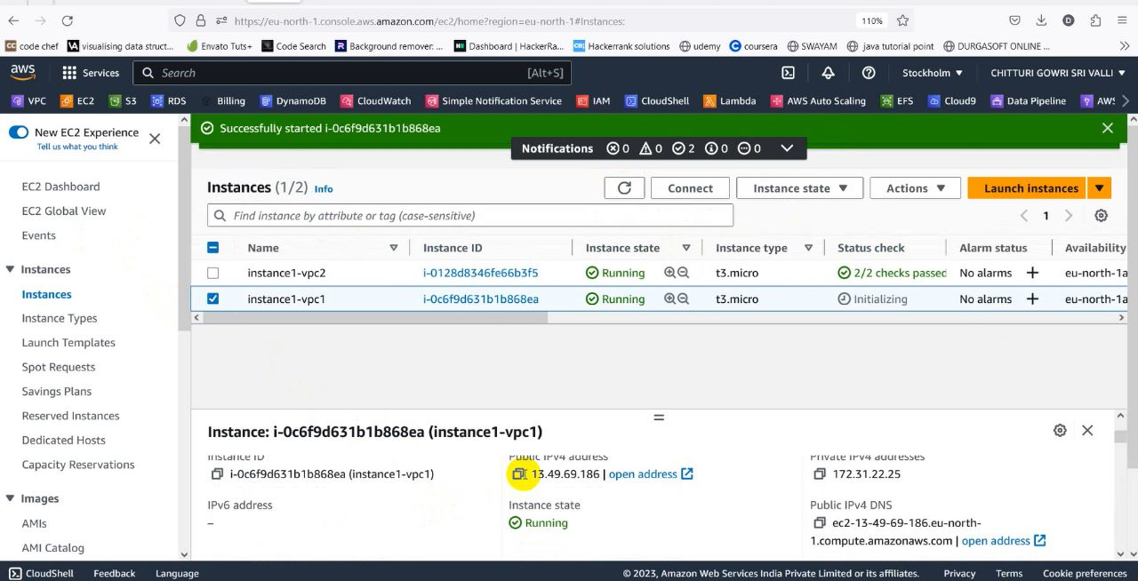

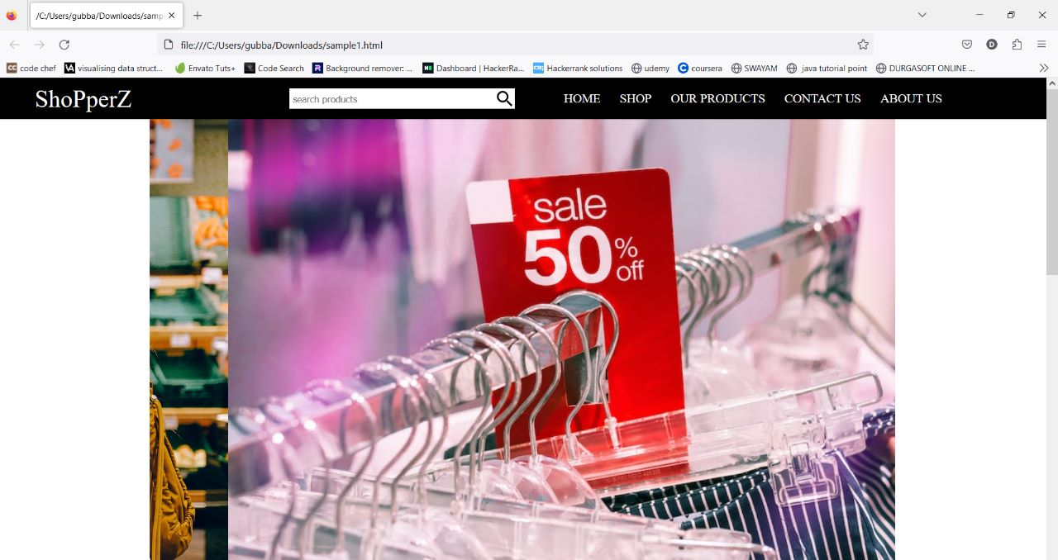

**Sub Service:Elastic Ip**



* Click on EC2and go to Elastic Ip
* Now click on alloacte elatic IP address and create it
* Then associate this elastic Ip address.This Elastic Ip is used to avoid 404 Error in our created website

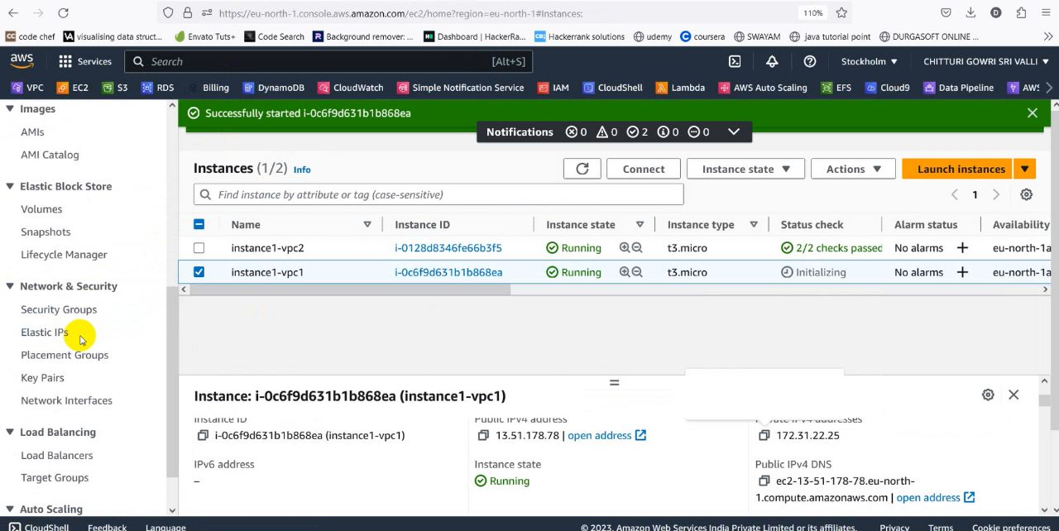

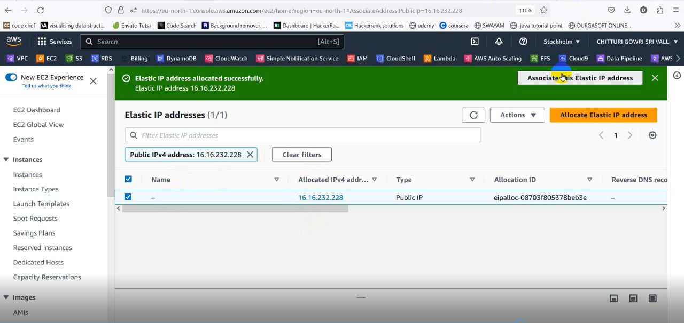

**Service 9:AWS Glue**



* To import the data from S3 to rds ,we are using the third party tool which is known as AWS Glue service
* Go to AWS Glue and create Crawlers with the name s3-rds-crawler
* Then we add a data source i.e S3 bucket1-vpc1

**Sub Service: Crawler**



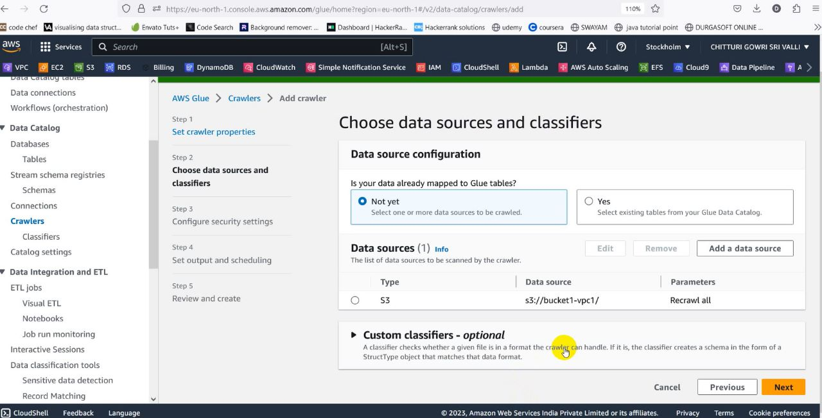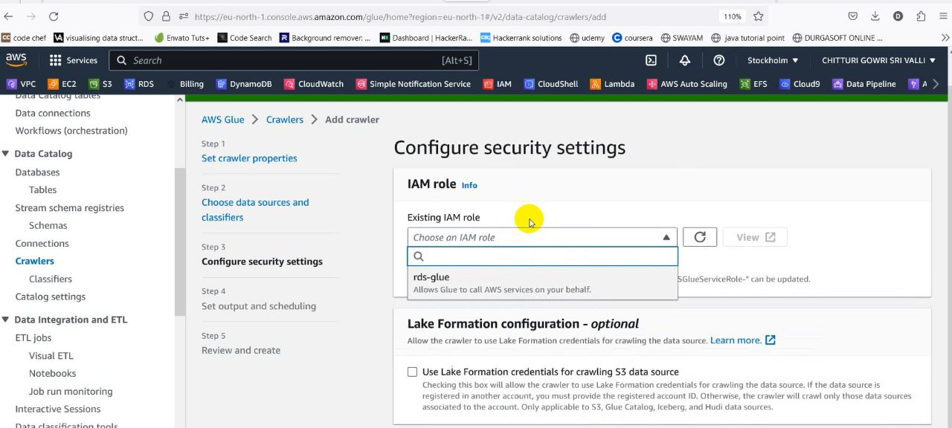

* After creation of the crawler,click on run

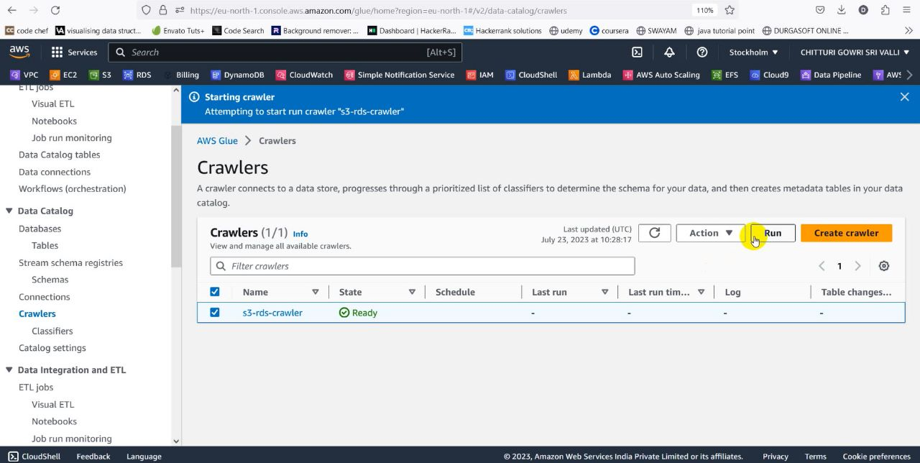

* Meanwhile create a database with name temp1
* After the successful execution of crawler ,the tables which we want to import from S3 bucket will be imported into the tables of database created in the AWS Glue

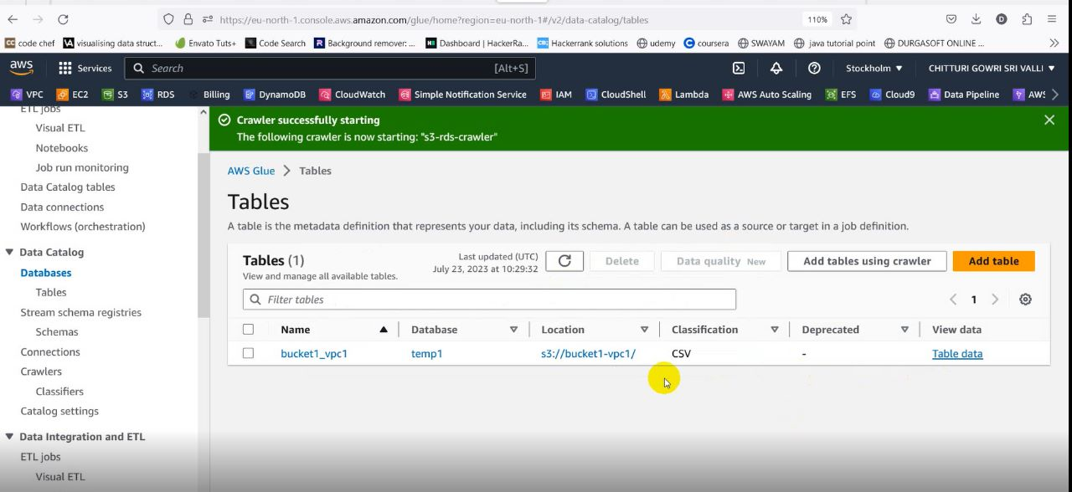

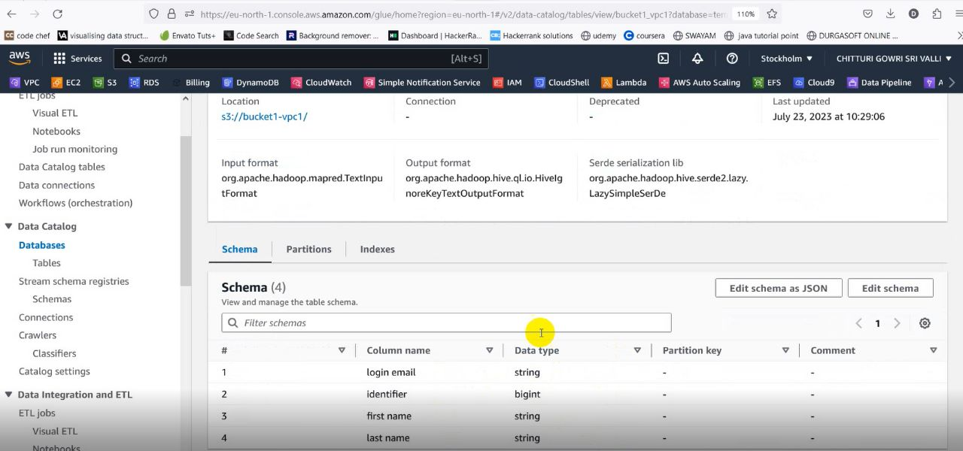

**Service 10:IAM**



* IAM is used in tranfer of data within two buckets in the same region

On behalf of Lambda.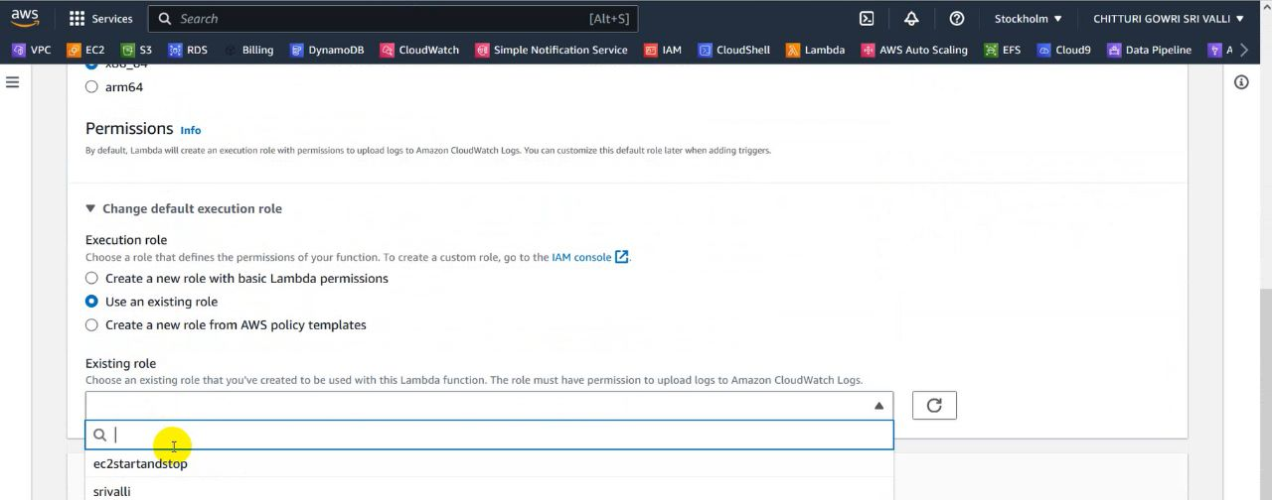

* A role created on behalf of EC2 using lambda function to control the state of an instance by deploying the code in lambda function

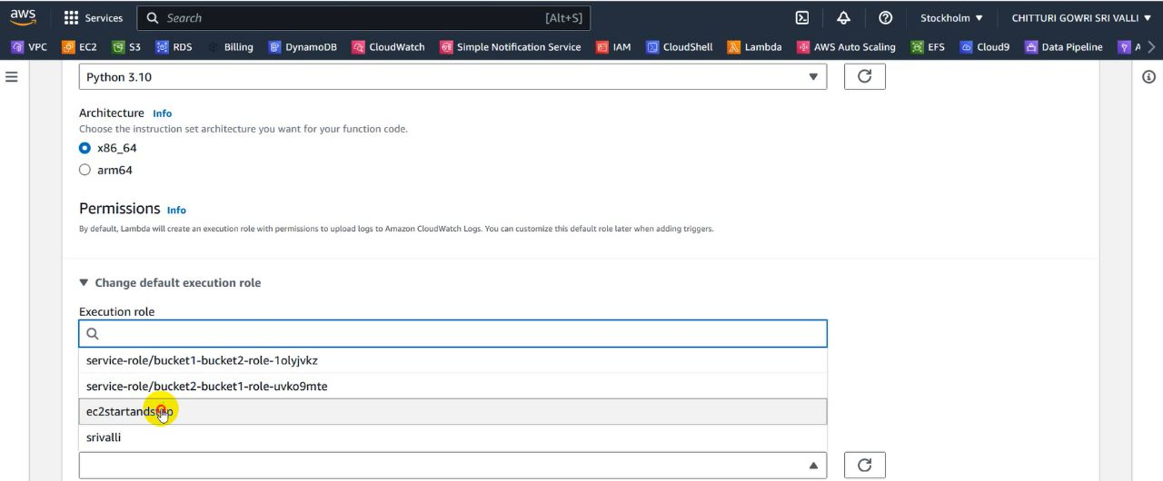

* In AWS Glue,while we creating the crawler we will give a role by giving the permisiions s3fullaccess,rdsfullaccess,glue

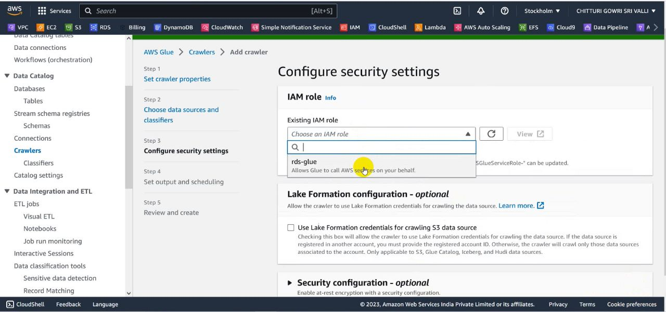

**Service 11:Relational Database Service[RDS]**

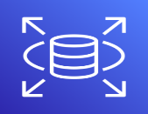

* Go to RDS and click on create a database

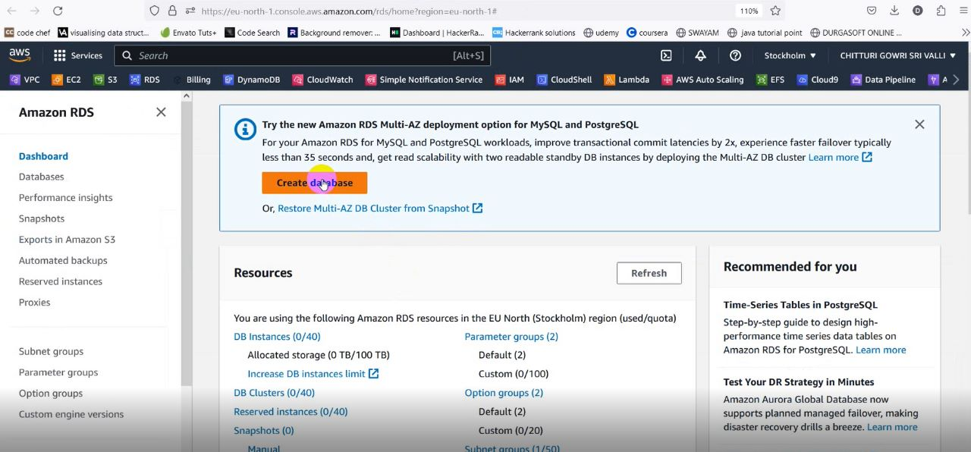

* Create a database using MySql Engine by using default vpc and scurity groups

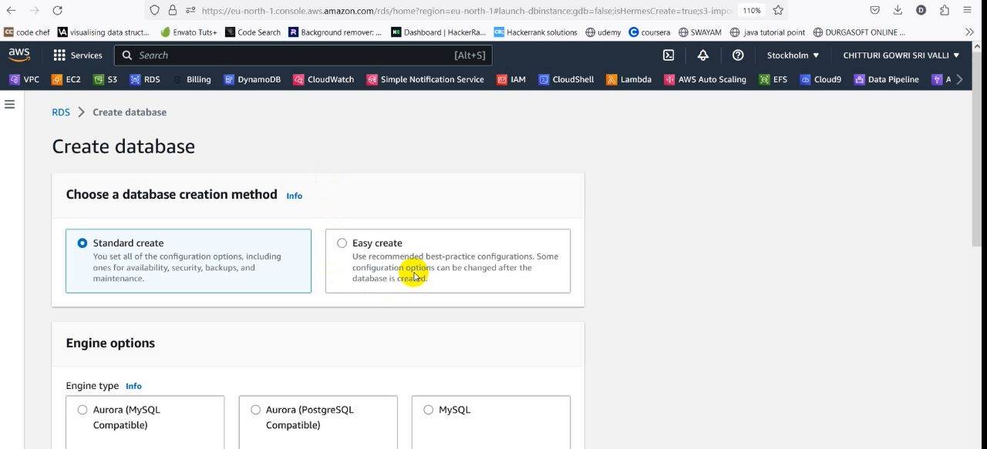

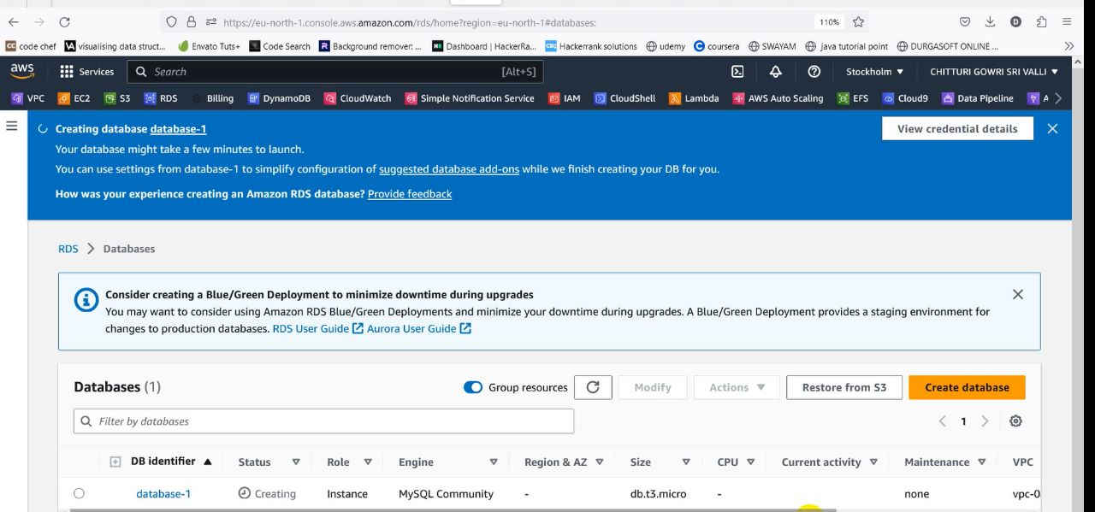

* Here we created the database with name database1

**Service 12: Data base Migration Service (DMS)**

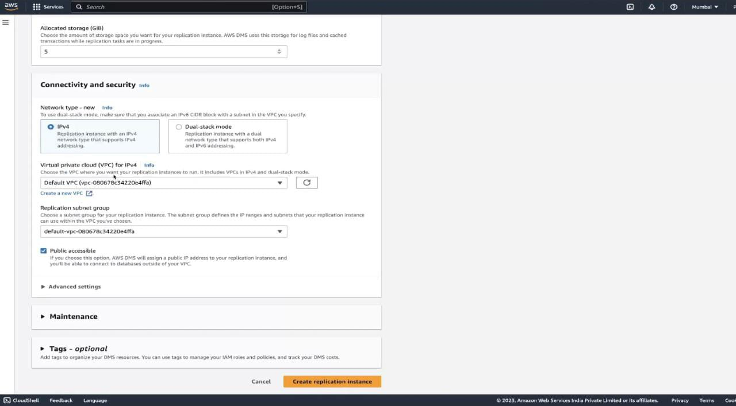

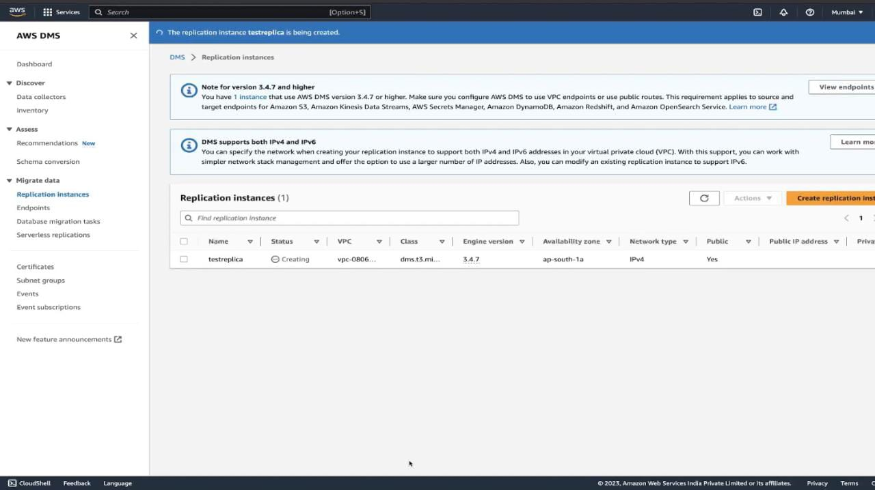

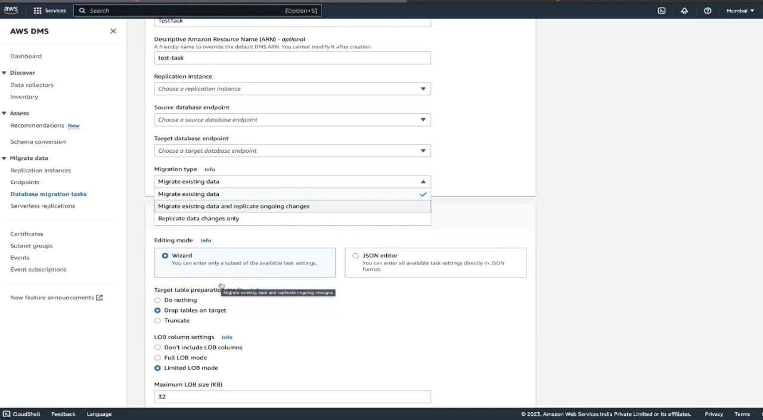

**Conclusion:**

So,This is our Architecture and implementation in detail the total senario explains how it can transfer data between two Buckets in same region and storing this data in DynamoDB by eliminating duplicates. This fine Architecture gives deep insights on how to manage the large sets of data. A point to be noted here is that the Architecture not only focused on how the data is preside over but also concentrates on the process of interaction with users and this all results in maintaining a trivial line of business.

**Ultimately the outcome is :**

**A real-time small-scale application (Mart)**